

**TRIBHUVAN UNIVERSITY**

**INSTITUTE OF ENGINEERING**

**IOE THAPATHALI CAMPUS**

**A Minor Project Report**

**On**

**Visualization of Solar Radio Outburst**

**Submitted By:**

Rabin Nepal (073/BEX/331)

Rhimesh Lwagun (073/BEX/333)

Sanjay Rijal (073/BEX/342)

Upendra Subedi (073/BEX/347)

**Submitted To:**

DEPARTMENT OF ELECTRONICS AND COMPUTER ENGINEERING

IOE THAPATHALI CAMPUS

KATHMANDU, NEPAL

August, 2019

# DECLARATION

We hereby declare that the report of the project entitled **“Visualization of Solar Radio Outburst”** which is being submitted to the **Department of Electronics and Computer Engineering, IOE Thapathali Campus**, in partial fulfillment of the requirements for the award of the Degree of Bachelor of Engineering in Electronics and Communication Engineering, is a bona fide report of the work carried out by us. The materials contained in this report has not been submitted to any University or Institution for the award of any degree and we are the only author of this complete work and no sources other than listed here have been used in this work.

Rabin Nepal (Class Roll No: 073/BEX/331)

Rhimesh Lwagun (Class Roll No: 073/BEX/333)

Sanjay Rijal (Class Roll No: 073/BEX/342)

Upendra Subedi (Class Roll No: 073/BEX/347)

**Date**: August, 2019

# CERTIFICATE OF APPROVAL

The undersigned certify that they have read and recommended to the **Department of Electronics and Computer Engineering, IOE, Thapathali Campus**, a minor project work entitled “**Visualization of Solar Radio Outburst**” submitted by **Rabin Nepal, Rhimesh Lwagun, Sanjay Rijal and Upendra Subedi** in partial fulfillment for the award of Bachelor’s Degree in Electronics and Communication Engineering. The Project was carried out under special supervision and within the time frame prescribed by the syllabus.

We found the students to be hardworking, skilled and ready to undertake any work related to their field of study and hence we recommend the award of partial fulfillment of Bachelor’s degree in Electronics and Communication Engineering.

Project Supervisor

Mr. Saroj Shakya

Department of Electronics and Computer Engineering, IOE Thapathali Campus.

External Examiner

Mr. Suramya Sharma Dahal

Department of Electronics and Computer Engineering, IOE Pulchowk Campus.

Project Coordinator

Mr. Dinesh Baniya Kshetri

Department of Electronics and Computer Engineering, IOE Pulchowk Campus.

Mr. Kiran Chandra Dahal

Head of the Department,

Department of Electronics and Computer Engineering, IOE Thapathali Campus.

August, 2019

# ACKNOWLEDGEMENT

We would like to thank our project supervisor Mr. Saroj Shakya for all the guidelines and motivation he has provided. Furthermore, our lecturers and classmates who have helped us directly and indirectly deserve our thanks. We would like to express our gratitude to Mr. Sunil Sera Karki for providing us with proper guidance. We would also like to acknowledge with much appreciation the help provided by Orion Space Nepal. Finally, we are very thankful to the **Department of Electronics and Computer Engineering, IOE Thapathali Campus** for providing us this opportunity to conduct this project.

# ABSTRACT

This project is about designing an instrumentation system capable to receive solar radio outbursts ranging from 30 MHz to 150 MHz via Log Periodic Dipole Array (LPDA) antenna and visualizing the received radio outburst signal in terms of radiation pattern, frequency vs. gain, frequency vs. SWR and frequency vs. Impedance graphs. Furthermore, the data is analyzed for predictions in the region of consideration which includes radio black-outs, GPS interference and space weather. This paper explains the details to understand the solar outburst phenomenon, the key to understand space weather, its interference with GPS and communication systems and to develop the system to visualize the frequency spectrum and the occurrence of solar outburst in it.

*Keywords: Bremsstrahlung radiation, Cherenkov radiation, continuum, coronal mass ejection,*  *gyromagnetic radiation, Solar flare, magneto hydrodynamic shock waves,* *proton emission, Radiation, SDR, Solar radio outburst*, *solar wind,* *superheterodyne.*

**TABLE OF CONTENTS**

DECLARATION i

CERTIFICATE OF APPROVAL ii

ACKNOWLEDGEMENT iii

ABSTRACT iv

List of Figures vii

List of Tables ix

List of Abbreviations x

1 INTRODUCTION 1

1.1 Background 1

1.2 Motivation 5

1.3 Problem Definition 5

1.4 Objectives 7

1.5 Project Scope and Application 7

1.6 Report Organization 7

2 LITERATURE REVIEW 9

3 REQUIREMENT ANALYSIS 13

3.1 Antenna 13

3.2 Vector Network Analyzer (VNA) 13

3.3 Balun 14

3.4 Coaxial cable 15

3.5 TV Tuner 15

3.6 Microcontroller 15

3.7 Software Defined Radio (SDR) 16

3.8 Matlab 16

4 SYSTEM ARCHITECTURE AND METHODOLOGY 17

4.1 System Block Diagram 17

4.1.1 Antenna 17

4.1.2 Balun 17

4.1.3 Coaxial Cable 18

4.1.4 Tuner 18

4.1.5 Mixer and Local Oscillator 18

4.1.6 Band Pass Filter 18

4.1.7 Amplifier 19

4.1.8 Processing Unit 19

4.1.9 USB 20

4.1.10 PC 20

4.2 Receiver Flowchart 21

5 IMPLEMENTATION DETAILS 22

5.1 Antenna 22

5.1.1 Design Theory of LPDA 22

5.1.2 Antenna Design Calculations 25

5.1.3 Algorithm for Calculations in MatLab 29

5.2 Balun 30

5.3 Coaxial cable 32

5.4 Receiver 34

5.4.1 Superheterodyne Receivers 34

5.4.2 SDR 35

5.4.3 Receiver Design 37

5.5 I2C 48

5.5.1 I2C timing 48

5.5.2 Data and Address format 49

6 RESULT AND ANALYSIS 53

6.1 Error analysis 59

7 FUTURE ENHANCEMENT 61

8 CONCLUSION 62

9 APPENDIX 63

A. Project Schedule 63

B. Project Budget 64

C. PCB Design Mechanism 65

D. Module Specifications 66

References 68

# List of Figures

Figure 2‑1: Usage-weighted dropped call rate for a wireless system base station, showing an enhanced level of dropped calls on the east-facing receivers near local sunrise. 11

Figure 4‑1: System block diagram 17

Figure 4‑2: Receiver Flowchart 21

Figure 5‑1: LPDA antenna 22

Figure 5‑2: relative spacing vs. periodicity graph 23

Figure 5‑3: 1:1 Balun 32

Figure 5‑4: Coaxial Cable construction 33

Figure 5‑5: Super heterodyne receiver 34

Figure 5‑6: SDR block diagram 36

Figure 5‑7: Digital and Analog tuner 38

Figure 5‑8: Tuner 39

Figure 5‑9: SN761672A Pin outs 40

Figure 5‑10: Symbol of Mixer 42

Figure 5‑11: Mixer Output 43

Figure 5‑12: Filtering the output from mixer 43

Figure 5‑13: Down converted signal 44

Figure 5‑14: Mixer simulation 44

Figure 5‑15: Equivalent electrical resonant circuit 45

Figure 5‑16: Common Emitter amplifier 46

Figure 5‑17: Input vs. output of log amplifier 47

Figure 5‑18: Log amplifier 48

Figure 5‑19: I2C Data bit 49

Figure 5‑20: I2C start, stop and repeated start condition 49

Figure 5‑21: Data and Address format 50

Figure 6‑1:  Frequency vs SWR graph with and without balun 54

Figure 6‑2:  Frequency vs Impedance graph with and without balun 55

Figure 6‑3: Frequency vs Resistance graph with and without balun 56

Figure 6‑4: Frequency vs. Capacitive reactance graph with and without balun 57

Figure 6‑5:  Signal at 53.119 MHz visualized using SDRSharp 58

Figure 6‑6:  Signal at 57.599 MHz visualized using SDRSharp 58

Figure 6‑7:  Signal at 84.5 MHz visualized using SDRSharp 58

Figure 6‑8:  Different FM signals visualized using SDRSharp 59

Figure 9‑1: Diode ring mixer 65

Figure 9‑2: RTL2831 SDR Receive 66

Figure 9‑3: measurement of characteristic impedance and SWR of LPDA antenna at 145.5 MHz using VNA 67

# List of Tables

Table 1‑1: Types of solar radio burst 4

Table 2‑1: Type III Radio Bursts Observed at Learmonth Observatory, 1-13 July 2002 9

Table 2‑2: Solar radio burst data by e-CALLISTIO from March to October, 2012 10

Table 5‑1: Table for lengths of LPDA elements 26

Table 5‑2: Table for separation between elements 27

Table 5‑3: Write data format 50

Table 5‑4: Test bits 51

Table 5‑5: Reference Divider ratio 51

Table 5‑6: band selection 51

Table 6‑1: Parameters comparison of LPDA 53

Table 9‑1: Gantt chart 63

Table 9‑2: Project Budget 64

# List of Abbreviations

AFWA US Air Force Weather Agency

CALLISTO Compound Astronomical Low cost Low frequency Instrument for

Spectroscopy and Transportable Observatory

CME Coronal Mass Ejection

FHNW Fachhochschule Nordwestschweiz

FTP File Transfer Protocol

GNSS Global Navigation Satellite System

HXR hard X-rays

I2C Inter-Integrated Circuit

IEEE Institute of Electrical and Electronics Engineers

IHY International Heliophysical Year

KHz Kilo Hertz

LOL Loss of Lock

LPDA Log-Periodic Dipole Array

LNA Low Noise Amplifier

MATLAB matrix laboratory

MHz Mega Hertz

NASA National Aeronautics and Space Administration

NOAA National Oceanic and Atmospheric Administration

SAW Surface Acoustic Wave

SCL Serial Clock

SDA Serial Data

SDR Software Defined Radio

SNR Signal to Noise Ratio

SRB Solar Radio Burst

SRM Solar Radiation Management

SWR Standing Wave Ratio

TV Television

TV1 Tuning Voltage

VCR Video Cassette Recorder

VNA Vector Network Analyzer

# INTRODUCTION

## Background

Solar activity is one of the most significant events affecting the climate, habitation and vegetation on the Earth. Solar activities include solar flares, coronal mass ejection, high-speed solar wind and solar energetic particles. Solar flare is a sudden intense burst of electromagnetic waves on the Sun occurred due to accelerate charged particles, especially electrons interacting  with plasma medium on the solar surface as a result of released magnetic energy associated with sunspots. Different types of radiation occur during solar activities such as bremsstrahlung radiation, gyromagnetic radiation, Cherenkov radiation and so on.

Bremsstrahlung radiation is the electromagnetic radiation produced due to sudden deceleration of charged particles deflected by another charged particle. It includes synchrotron radiation, cyclotron radiation and radiation due to beta decay. Bremsstrahlung emission during solar activities is free-free emission as emission occurs due to charged particles in plasma which are unbounded before and after the deflection. Bremsstrahlung radiation generally includes X-rays. Since the energy of the emitted particle is E=hf is smaller than the energy of incoming particle Ek, the continuous bremsstrahlung spectrum is limited by.

Gyromagnetic radiation is coherent electromagnetic emission caused by a bunch of charged particles in spiral motion in a magnetic field. It is classified as cyclotron and synchrotron radiation. Gyromagnetic emission from non-relativistic particles (v<<c) is cyclotron emission whereas that from relativistic particles (v ≈ c) is synchrotron emission. Gyromagnetic radiation plays a major role in emission of type IV solar radio bursts. [1]

Solar radio burst is an arrangement of frequency space with variation in time. Radio bursts originate from all levels of the solar atmosphere from inner chromosphere to outer corona. On the basis of frequency and time characteristics solar radio bursts are classified into seven types namely type I, type II, type III, type IV, type V, type VI and type VII. Radio bursts from type I to type V are basic radio bursts while type VI and VII are extensions of type III and IV respectively.

1. **Type I burst**

Type I bursts occur mainly due to solar winds. They are short, narrow-bandwidth bursts ranging from 80-200 MHz usually occurring in large numbers with underlying continuum. Normally single burst occur for one second everyday but during heavy solar wind type I burst can occur from hours to days.

1. **Type II burst**

Type II bursts occur due to coronal magneto hydrodynamic shock waves which occur due to solar flares, coronal mass ejection (CME) and proton emission. They are slow frequency drifts ranging from 20 - 150 MHz. They generally occurs for 3-30 minutes per day. They have drift rate, df/dt of 250 MHzs-1. The mechanism of generation of type II bursts is still a matter of ongoing research due to problems in determining the type of coronal magneto hydrodynamic shock wave associated with it.

1. **Type III burst**

Type III bursts are electron beam-driven radio burst related with solar flares, although not every flare is accompanied by type III burst. They are associated with the flare mechanisms such as energy release mechanism, acceleration process of non-thermal particles, propagation along open or closed field lines and generation of emission.  The main feature of such bursts is high drift rate, df/dt ≈ 100Mzs-1 in VHF and 75 ~ 700 MHzs-1 in UHF range. They have broad bandwidth ranging from 10 KHz to 1 GHz. Generally type III single burst occurs for 1-3 seconds while group bursts occur for 1-5 minutes per day. During high solar wind they can occur for several minutes to hours. Clustering of type III radio bursts have high correlation with hard X-rays (HXR) pre-burst structures so they are also called elementary flare bursts.

1. **Type IV burst**

Type IV bursts are complex broadband bursts with strong polarization. They are classified as stationary, moving and flare continua type IV bursts. Stationary type IV bursts occur due to solar flares and proton emission and characterized by broadband continuum with fine structure. They have a bandwidth of 20 MHz to 2 GHz and generally observed for several hours to days. In contrast moving type IV bursts occur for 30 minutes to 2 hours per day due to eruptive prominences and magneto hydrodynamic shock waves. They have a bandwidth of 20-400 MHz characterized by slow frequency drift and smooth continuum. As like stationary bursts, flare continua occur due to solar flares and proton emission but they have bandwidth of 25-200 MHz characterized by smooth continuum. They generally occur for 3-45 minutes per day.

1. **Type V burst**

Type V bursts appear as quasi-continuous emission having short-lived continuum. They are always associated with type III bursts and never occur in isolation. They arise from electrons in high coronal loops adjacent to open field lines traversed by type III electrons. They generally occur for 1-3 minutes per day with a bandwidth of 10-200 MHz. [2]

Table 1‑1: Types of solar radio burst

|  |  |  |  |  |
| --- | --- | --- | --- | --- |
| **Type** | **Characteristics** | **Duration** | **Bandwidth** | **Associated Phenomena** |
| I | narrow bandwidth, usually in large numbers with underlying continuum | single burst: 1 second  storm: hours-days | 80-200 MHz | Active regions, flares, eruptive prominences |
| II | slow frequency drift, usually strong intensity accompanied by second harmonic | 3-30 minutes | 20-150 MHz | Flares, proton emission, magneto hydrodynamic shock waves |
| III | fast frequency drift, can occur singularly, group and storms often with underlying continuum | single burst: 1-3 seconds  Storm: minutes-hours | 10 kHz-1 GHz | Active regions, flares |
| IV | Stationary type IV:  broadband continuum with fine structure | hours-days | 20 MHz-2 GHz | flares, proton emission |
|  | Moving type IV:  broadband, slow frequency drift, smooth continuum | 30 minutes - 2 hours | 20-400 MHz | eruptive prominences, magneto hydrodynamic shock waves |
|  | Flare continua type IV:  smooth continuum | 3-45 minutes | 25-200 MHz | flares, proton emission |
| V | quasi-continuum, follows some type III bursts | 1-3 minutes | 100-200 MHz | Active regions, flares |

## Motivation

Motivation is one of the factors, which encourages a person to the commitment of any action and play a crucial role as psychological determinant. There are many researches and projects which have been motivating us in different stages of our project. One of the sources of motivations is e-CALLISTO.

CALLISTO stands for Compound Astronomical Low cost Low frequency Instrument for Spectroscopy and Transportable Observatory. e-CALLISTO is an international network of solar radio spectrometers, a space weather instrument array that has been developed, deployed and maintained by the principal investigator of the project, Christian Monstein at the former Institute of Astronomy at ETH Zurich in view of the International Heliophysical Year (IHY 2007). All CALLISTO spectrometers together form the e-Callisto network. CALLISTO in addition is dedicated to perform radio-monitoring within its frequency range with 13'200 channels per spectrum. The major objectives of e-CALLISTO project is to observe solar radio bursts and their rfi-monitoring for astronomical science, educational purposes and outreach. The instrument natively operates between frequency range of 45-870 MHz using modern commercially available broadband cable-TV tuner CD1316 having a frequency resolution of 62.5 KHz. CALLISTO obtains data as FIT-files with up to 400 frequencies per sweep which are transferred via a RS-232 cable to a computer and saved locally with time resolution of 0.25 sec at 200 channels per spectrum (800 spectral pixels per second). The frequency range can be expanded to any range by switching-in a heterodyne up- or down-converter. Data from individual instruments are automatically uploaded by FTP to the central server at FHNW. The integration time is 1 mili sec and the radiometric bandwidth is about 300 KHz. The overall dynamic range is larger than 50 dB. [3]

## Problem Definition

Every 11 years or so, the Sun's magnetic field completely flips i.e. the Sun's north and south poles switch places due to constantly moving solar gases, which tangles, stretches and twists the solar magnetic field. Then it takes about another 11 years for the Sun’s north and south poles to flip back again. This is known as the solar cycle. This solar cycle affects the activity on the surface of the Sun such as sunspots, solar flares and coronal mass ejections. These eruptions send powerful bursts of energy along with charged as well as uncharged particles into space.

Because of the rapidly increasing role of technology, including complicated electronic systems, spacecraft, etc., modern society has become more vulnerable to a set of extraterrestrial influences (space weather) and thus requires continuous observation and forecasts of space weather. The major space weather events like solar flares and coronal mass ejections are usually accompanied by solar radio bursts, which can be used for a real-time space weather forecast. Although technology allows people to convert the sun's energy into electricity that same source of energy is also capable of completely knocking out the energy grid, potentially leading to catastrophic conditions. Electromagnetic energy from a flare event is capable of charging the atmosphere. This phenomenon would in turn induce an abnormally high charge in power lines, blowing out both power transformers and stations. Destruction of the power grid would lead to many different kinds of problems for society, including a loss of ability to refrigerate food items and the breakdown of sewage and waste processing systems.

A solar radio burst is the intense solar radio emission related to a solar flare and one of the extreme space weather events. If an SRB occurs with the enhancement in L band radio flux i.e. frequency range in radio spectrum from 1-2 GHz, it could influence the Global Navigation Satellite System (GNSS) signals as a result of direct radio wave interferences. SRB can reduce of signal to noise ratio (SNR) and instantaneous or long-period loss of lock (LOL) on GNSS signals, which determines the GNSS tracking status when the satellite signal is visible at a mask-angle greater than 5 degrees. Thus decreasing the observation quality, which subsequently will influence all the applications based on these observations such as radio occultation technique and precise GNSS positioning. SRB mainly affects stations located in the sunlit hemisphere during radio flux enhancement, while the strength of the influence depends on the solar incidence angle, antenna pattern, tracking algorithm and some other factors. [4]

Development of our system is required for the detection of such solar radio outbursts resulting from solar flares. As there is an effect of radio outburst on the RF communication, and the process is unpredictable, our system can find out the interruptible radio outburst that occurred at a fixed time.

## Objectives

The main objectives of this project are as follows:

* To design a system which can measure the solar radio outbursts.
* To visualize the relationship of solar radio outburst with frequency and time.

## Project Scope and Application

This project is about detection of sudden solar radio outburst caused by solar flares, coronal mass ejection or magneto-hydrodynamic shock waves that can cause radio blackouts. The designed antenna is capable of detecting the frequency of 30 MHz to 150 MHz. The frequency under consideration falls on VHF range. The frequency range of the system includes FM band, Aeronautical band and Metrological band. The received frequency range can be chosen as per requirements and the signal can be demodulated using SDR-Sharp. The received signal of considered frequency can also be visualized through waterfall on time and amplitude domain. However, our system has the following limitations:

* It cannot protect devices from the detected hazardous solar radio burst.
* It cannot detect radio burst lying in other bands except VHF.
* It cannot predict the occurrence of such bursts.
* It cannot predict the magnitude and duration of bursts.

The project is applicable in the following fields:

* For making transmitting and receiving station for aeronautical communication.
* For receiving meteorological information sent by different satellites.

## Report Organization

The report is organized into eight chapters. After this introductory chapter, chapter 2 which is ‘Literature Review’, describes the past researches on the solar radio bursts and its impacts on communication system. Chapter 3 summarizes the importance of hardware and software components used at different stages during project execution. Chapter 4 provides an account of the system architecture where the system block diagram is drawn and the purpose of each block and their interaction with the other blocks is described. Similarly, chapter 5 presents the implementation methods of hardware and software components along with their functions. The interfacing protocols such as the I2C protocol between the components is explained in this chapter. Chapter 6 is a major part of the report that compiles the results obtained from the LPDA antenna. Various graphs and signal flow models like water-fall model and frequency spectrum are realized in this section. Chapter 7 explains the extent upto which the research and results of our project can be extended in the future. Finally the ideas, results and analysis are concluded in chapter 8.

# LITERATURE REVIEW

There have been a number of attempts to identify solar radio bursts. Lobzin VV et al. in “Automatic recognition of type III solar radio bursts: automated radio burst identification system method and first observations” published by Space Weather magazine in 2009 proposed use of Radon transform for detection of type III solar radio bursts ranging from 25 to 180 MHz. The bandwidth was divided into low band from 25 to 75 MHz and high band from 75 to 180 MHz which were further divided into 401 sub-bands with linearly spaced central frequency. Type III Radio Bursts data observed at Learmonth Observatory on July 2002 are as shown in table 2.1. [5]

Table 2‑1: Type III Radio Bursts Observed at Learmonth Observatory, 1-13 July 2002

|  |  |  |  |
| --- | --- | --- | --- |
| **Date** | **Start Time**  **(UT)** | **End Time**  **(UT)** | **Frequency Range (MHz)** |
| 1 July 2002 | 0110 | 0111 | 25-180 |
| 3 July 2002 | 0214 | 0216 | 25-94 |
| 4 July 2002 | 0512 | 0723 | 25-180 |
| 7 July 2002 | 0412 | 0532 | 52-180 |
| 9 July 2002 | 0829 | 0829 | 25-106 |
| 13 July 2002 | 0626 | 0630 | 25-180 |

Compound Astronomical Low cost Low frequency Instrument for Spectroscopy and Transportable Observatory (CALLISTO), a programmable heterodyne receiver designed in 2006 in the framework of IHY2007 and nISWI by Christian Monstein, measures the solar activities. According to the observation of solar radio burst type III in 2015, solar wind speed was found to be 348 km/s with density 8.4 protons/cm3 and interplanetary magnetic field 13.4 nT. Along with this the X-ray flux data from solar monitor showed the occurrence of strong class flare which is believed to have high temperature due to strong magnetic field. [6]

According to Characterization of Selected Solar Radio Bursts Based on Solar Activity Detected by e-CALLISTO, a research paper published in International Letters of Chemistry, Physics and Astronomy,  e-CALLISTO in Malaysia had recorded the types of solar radio bursts from March 2012 to October 2012 whose data are as shown in the table 2-2.

Table 2‑2: Solar radio burst data by e-CALLISTIO from March to October, 2012

|  |  |  |  |  |
| --- | --- | --- | --- | --- |
| **Type** | **II** | **III** | **IV** | **V** |
| **Date** | 23rd October 2012 | 9th March 2012 | 5th March 2012 | 9th March 2012 |
| **Time(UT)** | 3:17-3:19 | 4:23-4:26 | 4:14-4:19 | 4:12:05-4:12:06 |
| **Range of frequency (MHz)** | 200-350 | 150-400 | 282-400 | 311-383 |
| **Active Region** | 1598 | 1429 | 1429 | 1429 |
| **Sunspot number** | 86 | 86 | 70 | 86 |
| **Radio flux (sfu)** | 144 | 140 | 120 | 140 |
| **Event** | Coronal Mass Ejections(CMEs) | Solar Flare type M 7.9 | New active region | Solar Flare type M 7.9 |
| **Duration** | 2 minutes | 3 minutes | 5 minute | 1 minute |

According to research on the effects of solar radio bursts on wireless systems accomplished by D.E. Gary, L.J. Lanzerotti, G.M. Nita and D.J. Thomson in 1999, usage-weighted call rates for wireless system base station at one of the states of the United States were found to be dropped at an enhanced rate on the east-facing receivers near local sunrise due to solar radio bursts exceeding about 1000 sfu (solar flux units, 1sfu =10-22 Wm-2Hz-1) as shown in the figure below. Such intense bursts caused significant interference when the Sun was within the base-station antenna beam. [7]

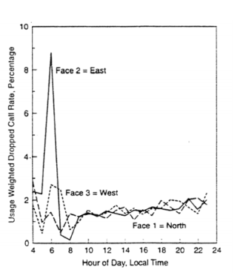

Figure ‑: Usage-weighted dropped call rate for a wireless system base station, showing an enhanced level of dropped calls on the east-facing receivers near local sunrise.

The National Aeronautics and Space Administration (NASA) and the National Oceanic and Atmospheric Administration (NOAA) - as well as the US Air Force Weather Agency (AFWA) keep a constant watch on the sun to monitor for flares and their associated magnetic storms. The number of solar flares increases approximately every 11 years, which means more flares are yet to come, from A-class (small flares) to X-class, big enough to send their radiation all the way to Earth. The most powerful flare measured with modern methods was in 2003, during the last solar maximum which was so powerful that it overloaded the sensors measuring it. Big flares and associated CMEs can create long lasting radiation storms that can harm satellites, communication systems, and even ground-based technologies and power grids. Flares detected on December 5 and December 6, 2006 triggered a CME that interfered with GPS signals being sent to ground stations. [8]

From the report of Integrating Space Weather Observation and Forecasts into Aviation Operations. Space weather phenomena (geomagnetic storms, solar radiation storms, solar flare radio blackouts, solar radio bursts, and cosmic radiation) can impact aviation operations. Effects include degradation or loss of HF radio transmission and satellite navigation signals; navigation system disruption; and avionics errors. The principal space weather hazard to humans is exposure to cosmic radiation, which is caused primarily by GCRs. These very energetic GCRs start interacting with the atmosphere at around 130,000 ft causing secondary particles to shower down into the denser atmosphere below. This “particle shower,” and the corresponding level of radiation dose, reach a maximum intensity at around 66,000ft (~20 km) and then slowly decrease with decreasing altitude down to sea level. [9]

According to “Impact of the 24 September 2011 solar radio burst on the performance of GNSS receivers”, a research paper published on Space Weather Vol. 11 on 28 May 2013 by V. Sreeja, M. Aquino and Kees de Jong, an intense solar radio burst occurred on 24 eptember 2011 at 12:34 UT and ended at 14:05 UT with solar flux peak at 13:04 UT, with a maximum power of 110,000 sfu at 1.415 GHz. The solar radio burst associated with M7.1 solar flare caused detectable reductions in the carrier-to-noise ratio (C/N0) of the GPS L1C/A, L2P, and L2C signals. Maximum reductions of 11.0, 22.0, and 10.0 dB Hz were observed for the GPS L1C/A, L2P, and L2C signals, respectively. The depth of observed C/N0 fades is modulated by the local solar incidence angle for GPS L1C/A and L2P signals, whereas such modulation was not observed for the GPS L2C signal. The solar radio burst also caused a significant impact on the recorded GPS pseudo range and carrier phase data. During the peak of the solar radio burst, some receivers (at locations where the local solar incidence angle was less than 30 degrees) experienced tracking difficulties, and gaps in pseudo range and cycle slips in the carrier phases were observed, which led to consequential effects on positioning accuracy. [10]

The solar activities such as solar irradiance, solar burst, solar wind and proton density in solar radiation play vital role in determining the weather conditions and biodiversity of the earth. The analysis of data obtained from solar activities can be beneficial in space research, weather forecasting, biodiversity management and solar radiation management (SRM). [11]

# **REQUIREMENT** **ANALYSIS**

## Antenna

Antenna is the forefront part of this project. Log periodic dipole array antennas have much broader frequency bandwidth than Yagi antennas thus they are better at operating in VHF and UHF band. Since our selected bandwidth lies in the VHF band, we selected LPDA as our receiving antenna which is capable of capturing electromagnetic signals ranging from 30 - 150 MHz. In addition to this, LPDA have same radiation resistance over wide range of frequencies due to which the Standing Wave Ratio (SWR) of the antenna remains almost constant whether at lowest point of frequency or at high end of bandwidth, which is our case is less than 1.5 as a result of which antenna becomes more immune to reflection of electromagnetic signals. Another major cause of selecting LPDA as receiving antenna is that it has frequency independent low gain and front-to-back ratio with high forward gain. As the direction of our transmitter which is the Sun, keeps on changing and we can’t even predict the direction of incoming solar radio bursts signals so, we require low gain antenna (8 dBi for designed LPDA) along frequency independent front-to-back ratio for constant power gain between front and rear of antenna.

LPDA has zigzag connection of feed and its element due to which feed needs to be taken from each element in zigzag way. To solve this problem two booms are used due to which number of feed points is reduced to one as the elements are connected to each boom alternately. The longest element calculation is dependent on the frequency of the lowest cut-off frequency while the lengths of remaining elements is independent of frequencies. They rather depend on the periodicity and relative spacing forming a logarithmic pattern of lengths of its elements. As a consequence of frequency independence of higher elements the length of antenna element is reduced logarithmically along with covering a wide range of frequencies.

## Vector Network Analyzer (VNA)

Vector Network Analyzer (VNA) is an instrument that measures the network parameters of an electrical network such as characteristic impedance in complex form along with its absolute value and Standing Wave Ratio (SWR) at tuned frequency. VNA used in our project was Color Graphic Antenna Analyzer SA-250. It was used to measure the characteristic impedance of LPDA antenna. In addition to this, it was also helpful in determining whether the signal was transmitted from balanced to unbalanced line with low SWR or not.

To measure the characteristic impedance of antenna VNA was connected to the feedpoint of LPDA using SMA connector extending from 50 Ohm coaxial cable and to confirm the proper operation of balun the output of balun was connected to VNA using SMA connector extending from 75 Ohm coaxial cable.

## Balun

The characteristic impedance of the designed LPDA antenna has a value of 238.3072 Ohms and while that of the coaxial cable used is 75 Ohms. According to maximum power transfer theorem, a circuit is able to transfer maximum power only when the source impedance is equal to the load impedance. In our case, source impedance is the impedance of the LPDA antenna and load impedance is coaxial cables (RG-6) impedance. Since the impedance of the source and the load is unmatched, power is reflected causing less power transfer along with standing wave distortion and interference with source. This problem is solved using a balun.

Balun is an electronic device that converts a balanced signal to an unbalanced signal or vice versa. For transmitting the signal received from the antenna to the receiver without any loss of signal or addition of noise, the signal is sent from balanced to unbalanced line and hence the name balun (balance to unbalance).

The designed balun consists of a toroid having 13 turns. By using a 116 Ohms resistor in parallel with balanced line source impedance was brought down to 78.0216 Ohms ≈ 75 Ohms. Thus we used 1:1 balun and converted the balanced signal from LPDA to the unbalanced coaxial line. The selection of balun was done by using the relation 3.1.

|  |  |
| --- | --- |
| Zprimary /Zsecondary=(Nprimary /Nsecondary)2 | *3.1* |

Where, Zprimary = characteristic impedance of antenna

Zsecondary = characteristic impedance of coaxial cable

Nprimary = primary winding on balun transformer

Nsecondary = secondary winding on balun transformer

## Coaxial cable

After the signal is converted to an unbalanced signal using balun, it is to be transferred to the receiver system. The receiver and the antenna is placed at a significant distance. Thus, a transmission medium is required to carry the signal to the receiver. Coaxial cable is used for this purpose. Coaxial cables are less prone to electromagnetic interference and are capable of handling high frequency signals with low losses. These are low cost cables and are readily available. However, an issue to be addressed while selecting a type of coaxial cable is the characteristic impedance of the coaxial cables. Cables with characteristic impedances of 75 Ohms and 50 Ohms are most prominent in the markets. Although, 50 Ohms cable is a better selection for our intended use, we used a cable of 75 Ohms (RG-6) as it is easily available in Nepal and has a lower price.

## TV Tuner

A digital TV/VCR tuner is the heart of our receiver. The tuner allows the receiver to pick up signals received by the antenna. A digital tuner tunes to a desired frequency, down-converts it and sends it to the output pins as Intermediate Frequency (IF) of 43.5MHz or other value depending on tuner. A digital tuner can be easily programmed by a microcontroller through the I2C interface. A desired frequency can be tuned in by simply sending equivalent bytes of data to the tuner.

## Microcontroller

As stated earlier, a digital tuner is the heart of our receiver. Similarly, a microcontroller is the brains of our receiver. To properly configure the digital tuner and operate it according to our needs, we need an I2C compatible microcontroller to send the required bytes to the tuner. Atmega328P from Atmel is a cheap and easily available 8-bit microcontroller that supports an I2C interface and has an integrated 10-bit ADC which is utilized further in the receiver. The chip is also facilitated with 23 general purpose input/output pins, 1KB of EEPROM, 32KB of Program Memory, 2KB of SRAM, and many other features. The microcontroller is also responsible for controlling the gain of the tuner by biasing the AGC pin of the tuner with appropriate voltage.

## Software Defined Radio (SDR)

An antenna receives all kinds of electromagnetic signals within its range. A receiver then tunes into a certain desired frequency. It is necessary to verify if the received signal is indeed the actual signal at that frequency tuned by the tuner. SDR or Software Defined Radio is a very useful and easy-to-use device that can be used to analyze and validate the received signals. It is a small but very complex device that implements the majority of hardware used in RF applications in software. It itself is a receiver which can tune in to a desired frequency. All the configurations can be set by using any of multiple softwares available for SDRs. SDR we used is RTL2831 SDR Receiver. We used this SDR to validate the working of our antenna and also to analyze the received signals.

## Matlab

MatLab is a mathematical software which we have used for data analysis and calculations. The antenna parameters such as length of antenna elements, spacing between the elements, required number of elements, characteristic impedance, spacing between booms and length of boom were calculated by programming in MatLab. MatLab also provides supporting packages for SDR hardware so that the data obtained from SDR can be analyzed graphically in MatLab. Data from the receiver can also be exported to MatLab and analyzed.

# SYSTEM ARCHITECTURE AND METHODOLOGY

## System Block Diagram

BPF

Processing Unit

PC

Local Oscillator

Mixer

Balun

Tuner

Amplifier

Processor

ADC

USB

Antenna

Control signal

Figure 4‑1: System block diagram

### Antenna

The antenna implemented in this project is a log periodic dipole array (LPDA) antenna. It receives signals in the VHF band ranging from 30MHz to 150 MHz. The signal received by antenna is sent to a tuner after its impedance is matched to the coaxial cable by the balun.

### Balun

An antenna is a balanced system and the coaxial cable is an unbalanced one. If these two systems were to be connected directly, without any impedance matching network, most of the received signal would reflect and very small percentage of the received signal would pass to the tuner. A balun works as an interface between antenna and coaxial cable and matches the impedance of the antenna with the coaxial cable and ensures the maximum transfer of signals.

### Coaxial Cable

Coaxial cable is responsible for carrying the received signal from the antenna to the tuner. It carries the signal with least interference and low losses. One end of the coaxial cable is connected to the balun and the other end is connected to the input of the tuner.

### Tuner

The receiver’s front end is a tuner. The signal from the antenna is fed to the tuner via a coaxial cable. The input to the tuner is all the signals received by the antenna. It is the tuner’s job to select the signal of desired frequency from this band of signals and down-convert it to an IF signal which is then amplified and sent to mixer for further processing. The tuner cannot perform all these actions by itself. It needs a microcontroller to send bytes of data through a dedicated communication channel. The output of the tuner is IF with frequency of 43.5MHz. It tunes to the frequency selected by the microcontroller and the gain is controlled by biasing the AGC of the tuner. The tuner down-converts the selected signal to IF signal having frequency of about 43.5MHz.

### Mixer and Local Oscillator

The local oscillator provides mixer with a constant oscillating signal, whose frequency is greater than the IF frequency received from the tuner. The mixer mixes the IF from the tuner and frequency from the local oscillator and outputs a signal having a lower frequency. To put it simply, the mixer down-converts the IF and generates a second IF.

The second IF generated has much lower frequency.

### Band Pass Filter

Along with the generation of second IF or down-converted signal, other stray signals are also generated. Signals of both sum and difference of the first IF and frequency from the LO are generated. Different order harmonics of these signals are also generated. In order to pass only the selected band of frequency, a band pass filter is employed. The filtered signal is then fed to an amplifier.

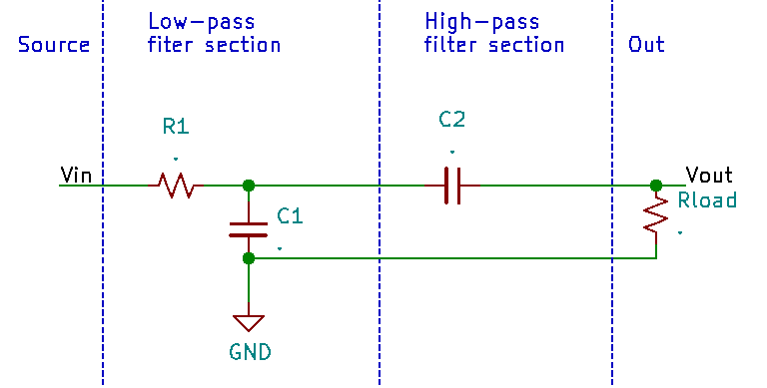

Figure ‑: Band Pass Filter

By connecting together a single Low Pass Filter circuit with a High Pass Filter circuit, passive RC filter was made. This circuit passes a selected range or “band” of frequencies to the amplifier, while attenuating all those outside of selected range.

### Amplifier

The signal received thus far has been attenuated throughout the process. In order to make these signals detectable by the processing unit, an amplifier is deployed after the band pass filter. The amplifier amplifies the signal without distorting any other properties of the signal. This amplified signal is then forwarded to the processing unit.

### Processing Unit

The processing unit consists of ADC and processor. The ADC samples the amplified signal and sends it to the processor. The processor then sends the sampled data to PC via USB.

The processor handles all the communication and control task. It communicates with the tuner in order to tune it to certain frequency and also controls the RF gain by controlling AGC pin of the tuner. It also communicates with PC for sending the sampled data and receiving commands.

### USB

The processor is connected to PC with USB-ttl as an interface between them. Since the processor is a lower level hardware device equipped with only basic level of communication protocols such as SPI, I2C, UART, etc. USB-ttl converts the Serial communication or say UART to USB protocol understandable by the PC and vice versa.

### PC

PC provides an interface between the user and the whole system. All the general commands can be programmed into the microcontroller with the help of a PC. PC also acts as an output unit for our instrumentation system. All the necessary data and graphs is realized on the display device of a PC.

## Receiver Flowchart

End

Is frequency greater than Fmax?

Set frequency to the tuner

True

Is tuner found?

To pc: Tuner not found

START

Initialize variable, set communication with pc, initialize ADC

Check for tuner

False

Sample data with ADC and store to array

Send data array to PC

Increment frequency

Set frequency equals to F min

Figure ‑: Receiver Flowchart

True

True

Is end of program?

False

False

# IMPLEMENTATION DETAILS

## Antenna

Basics of antennas can be deduced from the fundamental principle of electromagnetism and electric circuits. Antenna have two complementary functions:

1. Converting electromagnetic waves into voltage and current used by circuit
2. Converting voltage and current into electromagnetic waves which are transmitted into space.

Due to high bandwidth of 30-150 MHz, which lies in VHF band we designed a log-periodic dipole array antenna (LPDA). Depending on its design parameters, LPDA can be operated across a wide range of frequencies in VHF as well as UHF and over this range the gain, feed-point impedance, front-to-back ratio, etc. - will remain more or less constant. LPDA exhibits relatively low standing wave ratio (SWR) over a wide range of frequencies usually 2:1 and has frequency independent performance as well.

### Design Theory of LPDA

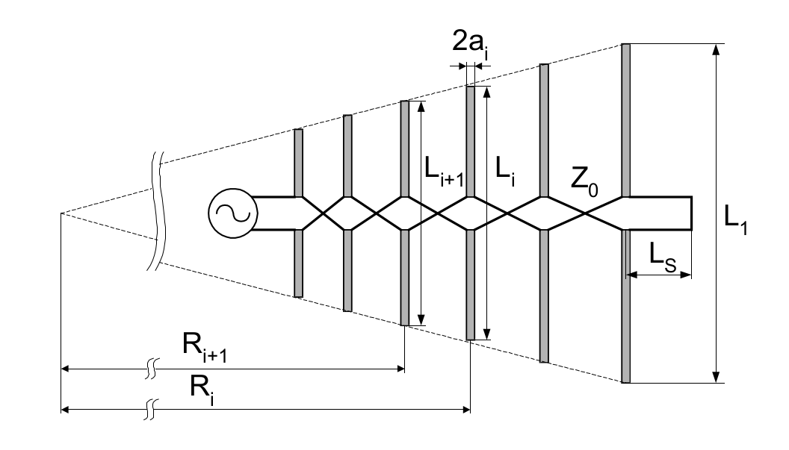

Figure 5‑1: LPDA antenna

The basic arrangement of LPDA is excited by a two-wire coaxial cable (antenna feeder) as shown in figure above. The elements of LPDA are excited with 180 degree phase shift with length and spacing between the elements varying in accordance with equation 1 and 2.

|  |  |
| --- | --- |
|  | *5.1* |

|  |  |
| --- | --- |
|  | *5.2* |

|  |  |
| --- | --- |
|  | *5.3* |

Where τ <1 is design constant called periodicity and σ is relative spacing of the elements.

The design input parameters are the nominal input resistance (R0), the desired gain (G) relative to isotropic radiator, and frequency range expressed as the lower (f1) and upper (f2) operating frequencies.

In our LPDA design R0 = 50 ohm (to achieve VSWR < 1.5), lower cutoff frequency (f1) is 30 MHz and upper cutoff frequency (f2) is 150 MHz with a gain of 8 dBi.

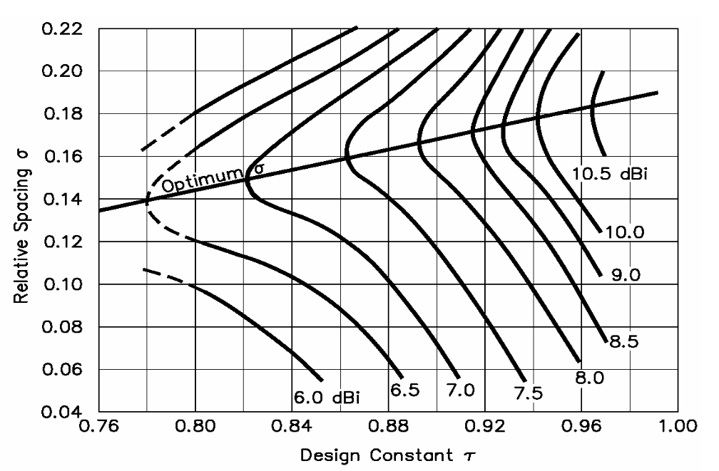

Figure 5‑2: relative spacing vs. periodicity graph

The corresponding value of periodicity (τ) and relative spacing (σ) for G = 8 dBi was determined from the above graph exhibiting linear relationship of τ and σ as

|  |  |
| --- | --- |
|  | *5.4* |

Relative bandwidth (B) of the system was calculated as,

|  |  |
| --- | --- |
|  | *5.5* |

Active region bandwidth (Bar), structure bandwidth (Bs) was calculated as,

|  |  |
| --- | --- |
|  | *5.6* |
|  | *5.7* |

The required number of dipole elements, length of longest element and relative spacing between elements were calculated as,

|  |  |
| --- | --- |
|  | *5.8* |
|  | *5.9* |

 Where C is the speed of EM waves in vacuum. The spacing between two element is given by,

|  |  |
| --- | --- |
|  | 5.10 |

For higher front-to-back ratio at the lowest frequency, the antenna feeder is shorted at a distance Ls behind the longest element. The short acts as a reflector; its distance from the longest element is given by

|  |  |
| --- | --- |
|  | *5.11* |

The distance between booms is calculated as,

|  |  |
| --- | --- |
|  | *5.12* |

Where, b is the diameter of feeder tube and

|  |  |
| --- | --- |
|  | *5.13* |

Where,

|  |  |
| --- | --- |
|  | *5.14* |

Here,

|  |  |
| --- | --- |
|  | *5.15* |

**Calculation of SWR:**

|  |  |
| --- | --- |
|  | *5.16* |

Where, ⍴= reflection coefficient

Z1 and Z2 are impedances of mismatched lines

|  |  |
| --- | --- |
|  | *5.17* |

Ideally, SWR is 1:1 which means that there is no power being reflected back to the source. Practically, a SWR of 1.2:1 is considered excellent in most cases. At SWR of 2:1, approximately 10% of the power is reflected back to the source. Not only does a high VSWR mean that power is being wasted, the reflected power can cause problems such as heating cables or causing amplifiers to fold-back.

Calculation of Return Loss and Mismatch Loss:

|  |  |
| --- | --- |
|  | *5.18* |

|  |  |
| --- | --- |
|  | *5.19* |

|  |  |
| --- | --- |
|  | *5.20* |

Receiving log-periodic dipole array antenna was designed using the above mathematical calculations. [12]

### Antenna Design Calculations

The antenna we use in our project for receiving solar radio outburst is Log Periodic Dipole Array. LPDA is a directional antenna having gain of 8 dBi. The antenna has 16 elements and two booms each of lengths 19 feet. Detailed calculations of antenna is done manually and also by MatLab program.

Bandwidth (B) = 150/30 = 5

Antenna impedance for maximum power transfer and directivity (R0) = 50 ohm

For Gain (G) = 8dBi, Relative spacing (σ) = 0.175

Design constant or Periodicity (𝝉) = 0.865

Diameter of element (2a) = 9 mm

Longest length of dipole (L1) = λ/2=c / (2f)=4.9965 m.

Active region bandwidth = 1.82765

Structure bandwidth (Bs) = B*Bar=9.13825

Number of dipole elements  = 16

Boom cross section dimension: 1” X 1”

Separation between booms = 6.887 cm

Slimness factor (S) = Li/2a, Savg = 196.51175

= 363.686

Feeder characteristic Impedance (Z0) = 238.3072

Length of next dipole element

Table 5‑1: Table for lengths of LPDA elements

|  |  |
| --- | --- |
| Elements | Length of half element λ/4 (in cm) |
| L1 | 249.825 |
| L2 | 216.098 |
| L3 | 186.925 |
| L4 | 161.862 |
| L5 | 139.862 |
| L6 | 120.98 |
| L7 | 104.648 |
| L8 | 90.520 |
| L9 | 78.3 |
| L10 | 67.729 |
| L11 | 58.586 |
| L12 | 50.677 |
| L13 | 43.835 |
| L14 | 37.981 |
| L15 | 32.799 |
| L16 | 28.371 |

The separation between each elements given in table below:

Table 5‑2: Table for separation between elements

|  |  |  |
| --- | --- | --- |
| S.N. | Ri-Ri+1 | Separation in cm |
| 1. | R1 – R2 | 87.44 |
| 2. | R2 – R3 | 75.63 |
| 3. | R3 – R4 | 65.42 |
| 4. | R4 – R5 | 56.59 |
| 5. | R5 – R6 | 48.95 |
| 6. | R6 – R7 | 42.34 |
| 7. | R7 – R8 | 36.63 |
| 8. | R8 – R9 | 31.68 |
| 9. | R9 – R10 | 27.41 |
| 10. | R10 – R11 | 23.70 |
| 11. | R11 – R12 | 20.50 |
| 12. | R12 – R13 | 17.74 |
| 13. | R13 – R14 | 15.34 |
| 14. | R14 – R15 | 13.27 |
| 15. | R15 - R16 | 11.48 |

**Calculation of SWR:**

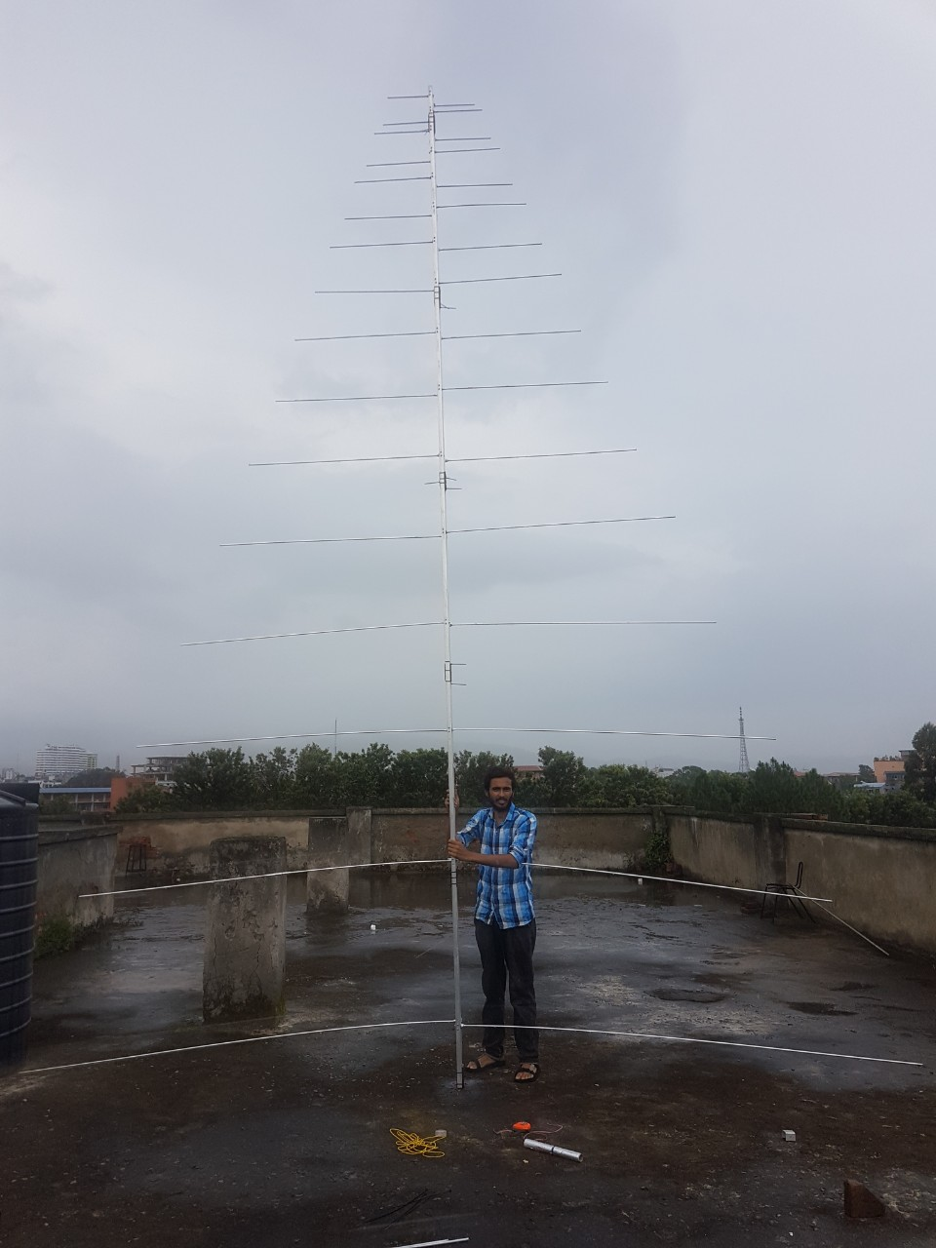

Figure ‑: Designed LPDA Antenna

### Algorithm for Calculations in MatLab

Algorithm for calculating antenna parameters in Matlab are as below:

**1.** Start

**2.** Enter values of lower cut-off frequency and upper cut-off frequency

**3.** Enter gain of LPDA in dBi

**4.** Calculate bandwidth (B) = upper frequency/ lower frequency

**5.** Calculate tau (τ) and sigma (σ) from graph

**6.** Calculate active region bandwidth (Bar**)**

**7.** Calculatemaximum wavelength = speed of EM wave in vacuum / lower frequency

**8.** Calculate number of elements (N)

**9.** Calculate characteristics impedance (Z0)

**10.** Calculate separation of two elements.

**11.** Calculate length of elements: Li = τ Li+1

**12.** Calculate spacing between the elements:

**13.** Repeat step 11 and 12 for 16 times.

**14.** Display all results.

**15.** End

## Balun

A balun is a type of electrical transformer used to connect an unbalanced circuit to a balanced one or vice versa. Baluns isolate a transmission line and provide a balanced output. The term is derived by combining balanced and unbalanced.

In a balun, one pair of terminals is balanced, that is, the currents are equal in magnitude and opposite in phase. The other pair of terminals is unbalanced; one side is connected to electrical ground and the other carries the signal. In our case, coaxial cable used to carry signals from antenna to receiver is unbalanced line and antenna is balanced line. Coaxial cable produces an extra current on outer side of its outer cable due to skin effect which makes the line unbalanced. The current produced needs to be eliminated before feeding the actual signal to receiver. A 1:1 balun is used to do so. If twisted pair cable is used instead of coaxial cable, there is no need of baluns as twisted pair cable is balanced transmission line. But, for twisted pair cable of length greater than ƛ/8, there occurs interference between two signals of cables which will degrade the quality of signal thus making it more difficult to extract.

Some baluns provide impedance transformation in addition to conversion between balanced and unbalanced signal modes; others provide no impedance transformation. For 1:1 baluns (no impedance transformation), the input and output are usually both 50 ohms and 75 ohms. The most common impedance-transformation ratio is 1:4 (alternatively 4:1). Some baluns provide other impedance-transformation ratios, such as 1:9 (and 9:1), 1:10 (and 10:1), or 1:16 (and 16:1). Impedance-transformer baluns having a 1:4 ratio are used between systems with impedances of 50 or 75 ohms (unbalanced) and 200 or 300 ohms (balanced). Most television and FM broadcast receivers are designed for 300-ohm balanced systems, while coaxial cables have characteristic impedances of 50 or 75 ohms. Impedance-transformer baluns with larger ratios are used to match high-impedance balanced antennas to low-impedance unbalanced wireless receivers, transmitters, or transceivers. In order to function at optimum efficiency, a balun must be used with loads whose impedances present little or no reactance. Such impedances are called "purely resistive."  As a general rule, well-designed communications antennas present purely resistive loads of 50, 75, or 300 ohms, although a few antennas have higher resistive impedances.

The balanced terminals of some baluns can be connected to an unbalanced system. One terminal of the balanced pair (input or output) is connected to ground, while the other is connected to the active system element.  When this is done, the device does not operate as a true balun, because both the input and the output are unbalanced. A balun used in this way has been called a "un-un" (for "unbalanced-to-unbalanced"). Some baluns can work as an impedance transformer between two unbalanced systems if there is little or no reactance.  But certain types of baluns do not work properly when connected in this manner. It is best to check the documentation provided with the device, or contact the manufacturer, if "un-un" balun operation is contemplated.

When the balun is built using transformer-like windings, it can also provide resistive source to load impedance matching by selection of appropriate primary/secondary turns ratio as given by equation 3.1.

To match the impedance of LPDA and coaxial cable, at first the characteristic impedance of antenna was reduced to nearly 75 Ohms by connecting a 110 Ohm 1Watt resistor across the balanced line.

Ohms

Where, Z0 = characteristic impedance of antenna

R = characteristic impedance of coaxial cable

To transfer balanced signal to unbalanced line 1:1 balun was made as:

Nprimary/Nsecondary=75.260575

=1.0017:1 ≈ 1:1

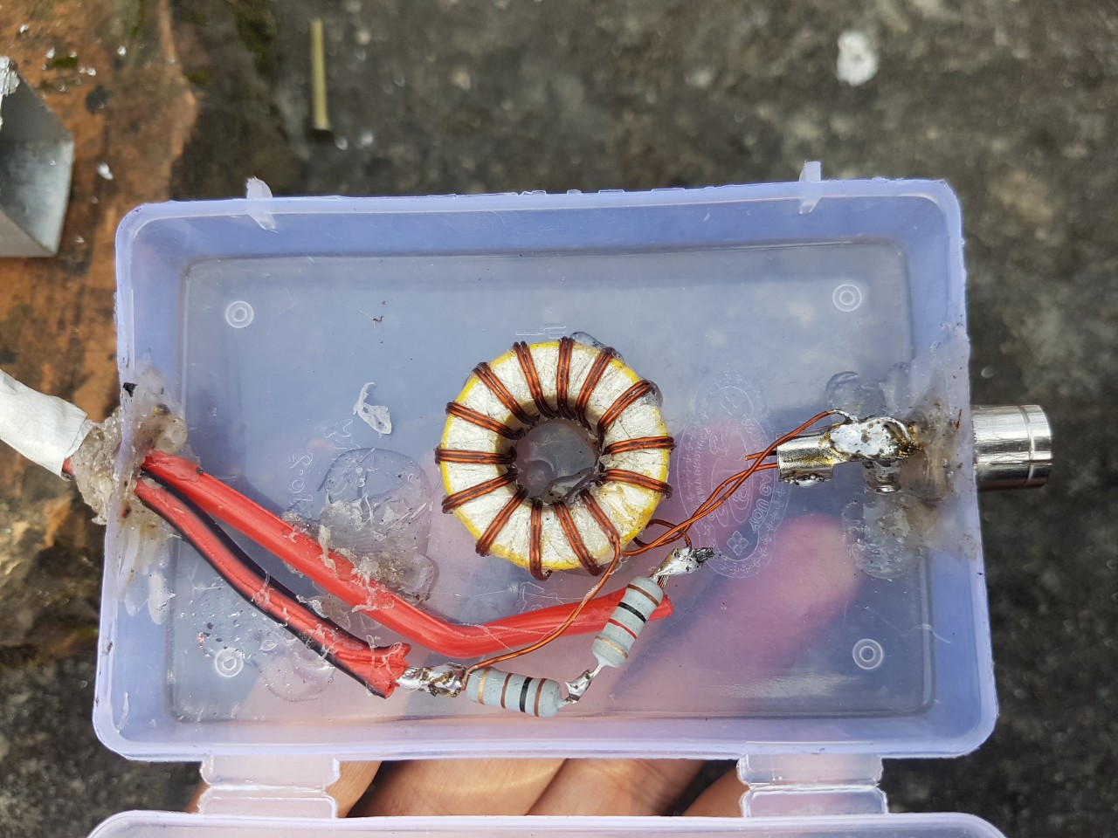

Figure 5‑4: 1:1 Balun

Similar to baluns, UN-UN stands for unbalanced to unbalanced. It is an interface between two unbalanced lines i.e. coaxial cable having different impedances. UN-UN transformer is used for matching impedances between two lines to avoid the reflection of signals while connecting two coaxial cables of different impedances.

To connect 75 ohm cable to 50 ohm cable, we need a UN-UN of transformation ratio of 1.22:1. The transformation ratio is given by the formula:

## Coaxial cable

Coaxial cable is a two conductor electrical cable consisting of a center conductor and an outer conductor with an insulating spacer between the two. It was first commercially implemented in the early 1940s. It consists of four primary components as follows:

* A core copper wire, which serves as the primary channel.
* A dielectric plastic insulator, which surrounds the copper core.
* A braided copper/aluminum sheath enclosing the dielectric.
* The last layer, called the Jacket, is generally made from PVC.

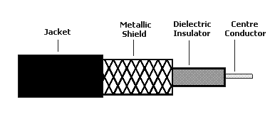

Figure 5‑5: Coaxial Cable construction

Normally, the shield is kept at ground potential and a signal carrying voltage is applied to the center conductor. The braided metallic shielding is used to protect the signal from external noise and crosstalk that could cause interference and possibly corrupt the data. The Jacket is used to protect the inner layers from physical damage.

Coaxial cables tend to carry signals at a greater distance and are a good choice for weak signals, due to their layered protection. There are several types of coaxial cables, which are classified by the inner copper core diameter and number of protective sheaths.

The advantage of coaxial design is that electric and magnetic fields are restricted to the dielectric with little leakage outside the shield. Further, electric and magnetic fields outside the cable are largely kept from interfering with signals inside the cable.

The coaxial cable we used is RG-6 which has the following features:

* Has a characteristic impedance of 75 ohms
* Size of core conductor is 18 awg (1.024 mm)
* Diameter of cable is 6.99 mm
* Dielectric type   polythene
* Capacitance 20.6 pF/feet

## Receiver

A receiver is a hardware module or device used to receive signals of different kinds, depending on the context of the application. It may receive analog electromagnetic signals or waves, or digital signals through wired or wireless media. It is a device that receives and decodes signals and then conditions or transforms them into something that another machine or computer understands. There exists many types of receivers. One of the most famous receiver used in RF field is Super-heterodyne.

### Superheterodyne Receivers

A superheterodyne receiver, often shortened to superhet, is a type of radio receiver that uses frequency mixing to convert a received signal to a fixed IF which can be more conveniently processed than the original signal.

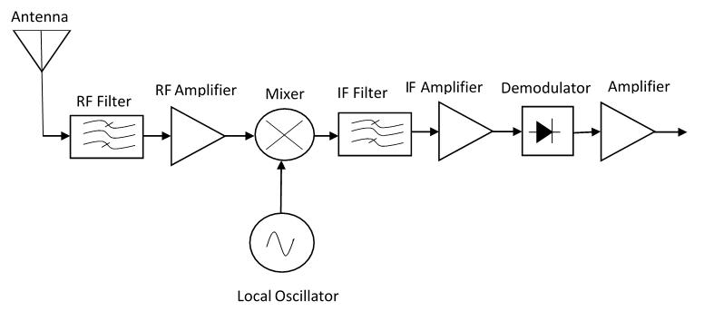

Figure 5‑6: Super heterodyne receiver

The idea of the superheterodyne receiver is to reduce the high frequency radio components of the incoming carrier to a fairly low, fixed value such as to be processed at the different stages of the receiver, and also to provide good stability, gain and proper selectivity and fidelity.

In superheterodyne receivers, after the signal enters through the antenna, it is typically amplified by an RF stage that operates only in the frequencies of interest region. Then, the signal is passed to the mixer which receives the local oscillator contribution by its other input. The local oscillator's frequency is set by the radio's tuning control. The mixer is in charge of translating the signal to the Intermediate Frequency (IF). Typically, the oscillator's frequency is set to a value that ensures that its difference from the desired signal's frequency is equal to the IF. For example, if someone would like to receive an FM station at 100.7MHz and the IF were 10.7MHz, the local oscillator should be placed at 90MHz.The operation is known as down conversion.

The next stage is a band-pass filter that attenuates every signal except a specific portion of the spectrum. The bandwidth of this stage limits the bandwidth of the signal that's being received. Common center frequencies for the IF stage are 455 kHz and 10.7 MHz for commercial AM and FM respectively. Likewise, for commercial FM, the bandwidth is approximately 100 kHz and for AM is above 5 kHz, consistent with the channel spacing that's 200 kHz for AM and 10 kHz for FM.

At the end, the demodulator recovers the original modulating signal from the IF amplifier's output employing one of several alternatives. For example, for AM an envelope detector is used, and for FM a frequencies discriminator. Further processing of the signal depends on the purpose for which the receiver is intended. In a common home radio, the demodulated output is passed to an audio amplifier that is connected to a speaker. Moreover, an amplification step is commonly placed before the demodulation block to carry the signal to an acceptable level for the demodulator circuit.

Superheterodyne radio receiver in spite of being more complicated than some of the other receivers offers many advantages in terms of performance, most importantly the selectivity. It is more efficiently able to remove unwanted and distorting signals than other kinds of receivers. [13]

### SDR

SDR or Software-defined radio is a concept according to which RF communication is achieved by using the software. It incorporates a significant amount of software-based signal-processing functionality. It is a radio communication system where components that have been typically implemented in hardware (e.g. mixers, filters, amplifiers, modulators/demodulators, detectors, etc.) are instead implemented by means of software on a personal computer or embedded system. IEEE defines SDR as “*Radio in which some or all physical layer functions are software defined.*”

Most receivers use a variable-frequency oscillator, mixer, and filter to tune the desired signal to a common intermediate frequency or baseband, where it is then sampled by the analog-to-digital converter. However, in some applications it is not necessary to tune the signal to an intermediate frequency and the radio frequency signal is directly sampled by the analog-to-digital converter after amplification. The traditional receivers have used conventional heterodyne schemes for almost a century. The superheterodyne internals blocks are shown in Fig 4.3. A basic understanding of superheterodyne architecture is necessary to distinguish this concept from the SDR receiver.

The basic concept of the SDR software radio is that the radio can be totally configured or defined by the software so that a common platform can be used across a number of areas and the software used to change the configuration of the radio for the function required at a given time.

The figure shows a block diagram of a software defined radio receiver.

LNA

BPF

MIXER

Local Oscillator

Low pass filter

USB

ADC

SDR

Figure 5‑7: SDR block diagram

In an ideal world, SDR would require only three hardware components: antenna, analog-to-digital converter, and a dedicated processor. The antenna is connected to the ADC which converts the analog signals from the antenna to a digital data. The output of the ADC is fed to a dedicated processor which processes the digital data and sends it to an end device where the configurations can be selected according to the data we need to acquire. Unfortunately, we don’t live in an ideal world. The main obstacle is the analog-to-digital converters; turns out it is pretty hard to design a converter that can convert quickly and accurately enough, even signals at nano volt level. For that reason, real SDR receivers use some hardware components, most commonly wide-band, low-noise amplifiers and band-pass filters. Low Noise Amplifier (LNA) is a specialized amplifier that amplifies a very low-power signal without significantly degrading its signal-to-noise ratio.. A band-pass filter is an electronic device or circuit that allows signals between two specific frequencies to pass, but that discriminates against signals at other frequencies. The analog signal from antenna is amplified using LNA and is passed to a band-pass filter.

These pre-processes the signal for the digital components. But using such hardware components reduces the flexibility of the receivers.  Software Defined Radios has some great advantages. First, it greatly reduces the amount of required specialized hardware components. And thus this decreases the overall cost of the system by a significant amount. Another great advantage is flexibility. It is not necessary to replace half of all the components to support new wireless protocol or modulation. Instead, it can be achieved just writing a few new lines of code.

### Receiver Design

#### TV/VCR Tuner

TV/VCR Tuners exist in basic two categories: Analog Tuners and Digital Tuners. The analog tuners use an input voltage of 0-28V to control the tuner VCO (Voltage Controlled Oscillator) which in turn tunes into the frequency corresponding to the applied voltage. It also consists of 3 input pins to select a band frequency. The tuning voltage also controls the input filter inside the tuner. The input RF is then mixed with the signal from the VCO and the output Intermediate Frequency (IF) is set to a certain value, typically 38.9 MHz.

The main disadvantage of an analog tuner is that it is difficult to provide a very stable tuning voltage to the VCO and to exactly find out which frequency the tuner is tuned in.

The digital tuner works very differently than an analog tuner. They use a PLL synthesizer circuit to tune into a set frequency. The synthesizer can be programmed to any frequency in the range supported by the tuner IC which is generally 45 to 860MHz. The synthesizer senses the frequency from the tuner VCO and compares it with the programmed frequency. The circuit then regulates the tuning voltage until the frequency from the VCO and the programmed frequency is equal and in phase with each other. The band selection and the tuning frequency is programmed onto the tuner IC by an I2C interface. The output from a digital tuner is very exact in frequency and is very stable. The only disadvantage with this type of tuner is that it needs a microcontroller capable of I2C interface.

IF out

TU (0-28)V

Analog Tuner

RF in

Filter

VCO

Mixer

Filter

PLL

VCO

RF in

Digital Tuner

Mixer

IF out

I2C

Figure 5‑8: Digital and Analog tuner

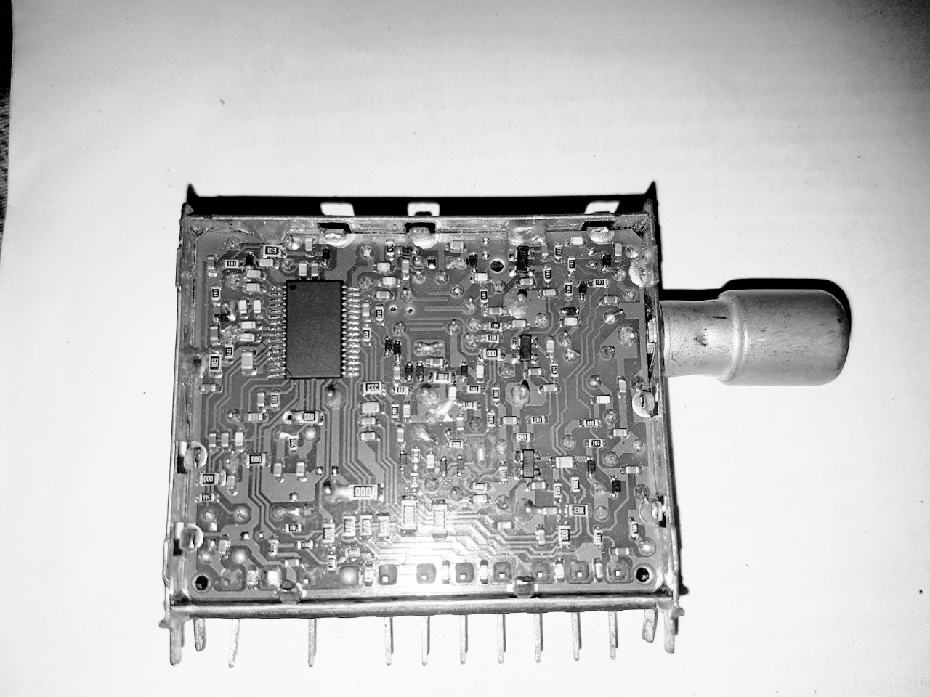

Figure 5‑9: Tuner

The tuner salvaged from an old TV used SN761672A as a tuner IC. It has the following pin configurations (right to left):

* AGC = AGC stands for Automatic Gain Control. This pin can be supplied a voltage from 0 to 12V depending on the gain required.
* TV1 = TV (Tuning Voltage) pin is the power to the PLL
* AS = AS (Address Selection) pin sets address for the tuner according to the bias voltage.
* SCL = I2C clock to the TV/VCR Tuner IC
* SDA = I2C data to the TV/VCR Tuner IC
* + 5V = Power supply to the TV/VCR Tuner IC
* + 5V = Power supply to the TV/VCR Tuner IC
* TV2 = Not defined in the datasheet
* IF = Output IF

SN761672A is a single chip synthesized tuner IC designed for TV/VCR tuning systems. The circuit consists of a PLL synthesizer, 3-band local oscillators and mixer, a 30-V tuning amplifier, and four NPN band switch drivers. It is available in a small package outline. The 15-bit programmable counter and reference divider is controlled by I2C bus protocol. Tuning step frequency is selectable by this reference-divider ratio for a 4-MHz crystal oscillator.

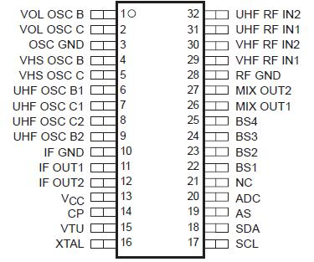

Figure 5‑10: SN761672A Pin outs

This tuner IC utilizes 15-bit programmable counter to tune into a certain frequency. It allocates a space of two bytes to write the equivalent value of the frequency to be tuned. The value of frequency to be tuned cannot be directly loaded onto the registers. It needs to be modified as explained in an example below:

Let us assume that it is needed to tune to 100MHz and the tuner outputs an Intermediate Frequency (IF) of 43.5MHz as specified in the datasheet. Since the tuner output has an IF frequency shift, it is necessary to program the tuner with a reception frequency that includes the shift. So, we calculate the frequency (F) to be written as:

Tuning Frequency (TF) = 100MHz

Intermediate Frequency (IF) = 43.5 MHz

F = TF + IF

   = 100MHz + 43.5MHz

   = 143.5 MHz

Therefore, we want to send data for tuning into 143.5 MHZ.

We now need to select the step size for the PLL. Steps of 62.4 KHz, 50 KHz and 31.2 KHz can be selected according to the values selected as 512, 640 and 1024 respectively. Step size is calculated as:

Step Size = (4 MHz * 8) / (reference divider ratio= (4 MHz * 8)/ 512

= 62.5 KHz

The tuner counts in frequency steps up to the programmed frequency. The number of steps required is calculated by dividing the programmed frequency by the step size. We calculate steps as:

Steps   = F / 62.5 KHz

  = 143.5 MHz/ 62.5 KHz

= 2296

Therefore we want the tuner to count 2296 steps. However, the tuner expects to receive this number in binary, not decimal. So, the steps must be converted from decimal to binary equivalent. The binary equivalent of 2296 is 0b0000100011111000.  This binary data is then separated into two bytes and written to the tuner through I2C interface.

#### Mixer

Mixer is an electrical circuit that creates new frequencies from two signals applied to it. A mixer takes an RF input signal at a frequency fRF, mixes it with a LO signal at a frequency fLO, and produces an IF output signal that consists of the sum and difference frequencies, fRF ± fLO. A bandpass filter follows the mixer and selects the sum (fRF + fLO) or difference (fRF – fLO) frequency. When the sum frequency is used as the IF, the mixer is called an upconverter; when the difference is used, the mixer is called a downconverter. The former is typically used on the transmitting side, the latter on the receiving side.

Output Signal

Input Signal

Local Oscillator

Ideal Mixer

Figure 5‑11: Symbol of Mixer

Let us suppose that the input to the mixer is RF and LO signal represented by vRF and vLO,

The output of the mixer is a product of two input signals. Let vout represent output. Then,

We have a trigonometric identity as:

Applying the identity, we have:

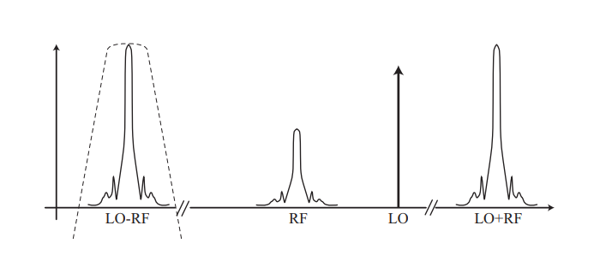

Figure 5‑12: Mixer Output

We can now select either the upper or lower band by filtering the output of the mixer.

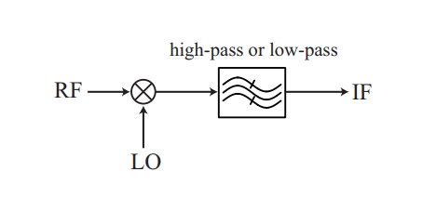

Figure ‑: Filtering the output from mixer

 Passing the output from the mixer through a low pass filter, we can obtain an IF as shown in the diagram below:

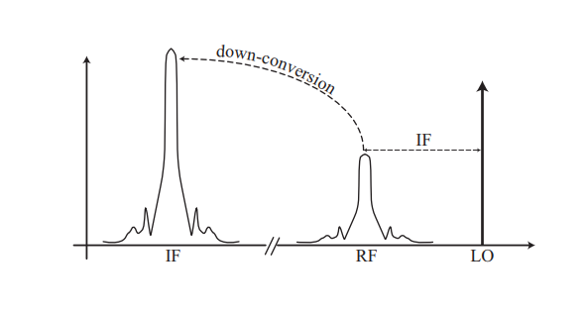

Figure 5‑14: Down converted signal

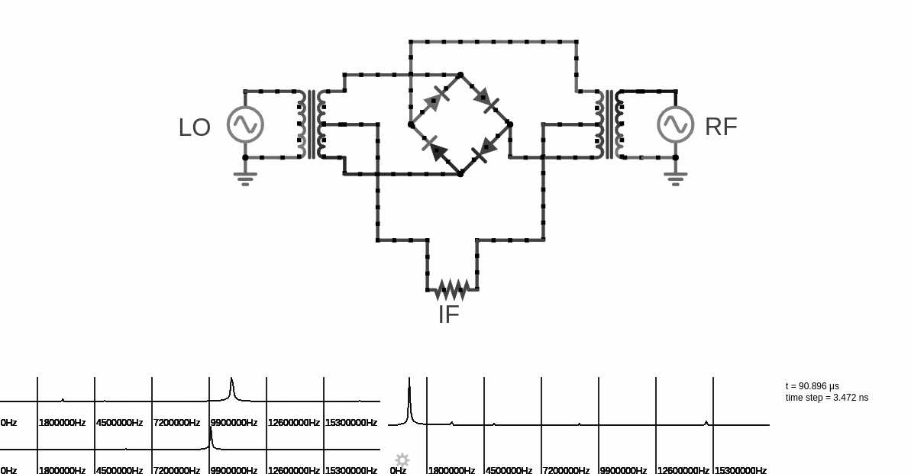

Figure 5‑15: Mixer simulation

#### Local Oscillator

A local oscillator (LO) is an electronic oscillator used with a mixer to change the frequency of a signal. Local Oscillator generates signal that is precisely IF (Intermediate Frequency) greater than the selected frequency signal. A local oscillator is mostly combined with mixer, and that unit is called convertor. The signal thus generated is down converted to a frequency that the receiver is able to handle.

A crystal oscillator are fixed frequency oscillators, having the same circuits as other types of oscillators, with difference being the crystal replacing the tuned circuit. In crystal oscillator, the crystal vibrates as a resonator and the resulting frequency determines the oscillation frequency.

A crystal can be represented by an equivalent electrical resonant circuit as:-

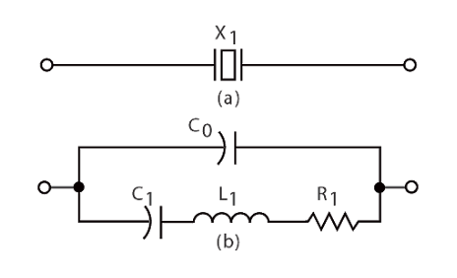

Figure 5‑16: Equivalent electrical resonant circuit

Inductor L1 and capacitor C1 represents the electrical equivalent of crystal mass and compliance, the resistor R1 represent the friction of crystal’s internal structure and C0 represents capacitance formed due to mechanical moulding of the crystal. It can have two resonant frequencies, series resonance and parallel resonance. Series resonance occurs when the reactances produced by capacitance C1 and inductance L1 becomes equal and opposite. Thus during this condition impedance is very low, equal to resistance R1. Parallel resonance occurs when the reactance of series resonant leg becomes equal to reactance produced by capacitance C0. During this condition the crystal offers very high impedance to the external circuit.

#### Common Emitter Amplifier

The signal or IF from the mixer is weak so for further processing Common Emitter Amplifier is implemented as an amplifier to increase the power of the IF.

The Amplifier is a circuit that is used for amplifying a signal. The input signal to an amplifier will be a current or voltage and the output will be an amplified version of the input signal. Transistor amplifier is used following the Common Emitter transistor configuration, as it has a gain that is positive and greater than unity.

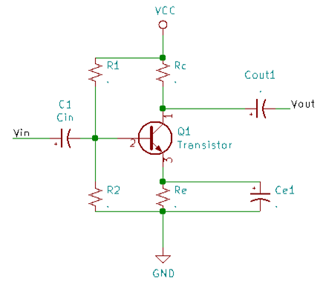

Figure 5‑17: Common Emitter amplifier

This is RC coupled amplifier circuit, where Capacitor Cin is the input DC decoupling capacitor which blocks any DC component if present in the input signal. If any external DC voltage reaches the base of Q1, it will alter the biasing conditions and affects the performance of the amplifier.R1 and R2 are the biasing resistors. This network provides the transistor Q1’s base with the necessary bias voltage to drive it into the active region. Cout is the output DC decoupling capacitor. It prevents any DC voltage from entering into the succeeding stage from the present stage. If this capacitor is not used the output of the amplifier (Vout) will be clamped by the DC level present at the transistors collector. Rc is the collector resistor and Re is the emitter resistor. Values of Rc and Re are so selected that 50% of Vcc gets dropped across the collector & emitter of the transistor. This is done to ensure that the operating point is positioned at the center of the load line.

#### Log Amplifier

A logarithmic amplifier, or a log amplifier, is an electronic circuit that produces an output that is proportional to the logarithm of the applied input. But the term log amplifier, as it is generally understood in communications technology, refers to a device which calculates the log of an input signal's envelope. The log amp gives an indication of the instant-by-instant low-frequency changes in the envelope, or amplitude, of the signal in the log domain in the same way that a digital voltmeter, set to "ac volts", gives a steady (linear) reading when the input is connected to a constant amplitude sine wave and follows any adjustments to the amplitude.

In general, the principal application of log amps is to measure signal strength, as opposed to detecting signal content. The log amp's output signal, which can represent a many-decade dynamic range of high-frequency input signal amplitudes by a relatively narrow range, is typically used to regulate gain. The classic example of this is using a log amp in an automatic gain control loop, to regulate the gain of a variable-gain amplifier. The receiver of a cellular base station, for example, might use the signal from a log amp to regulate the receiver gain. In transmitters, log amps are also used to measure and regulate transmitted power.

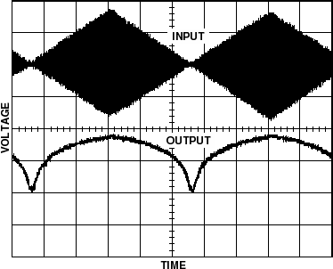

Figure 5‑18: Input vs. output of log amplifier

The figure shows a simplified diagram of a log amplifier. A 25MHz sinusoidal signal is provided to the input.

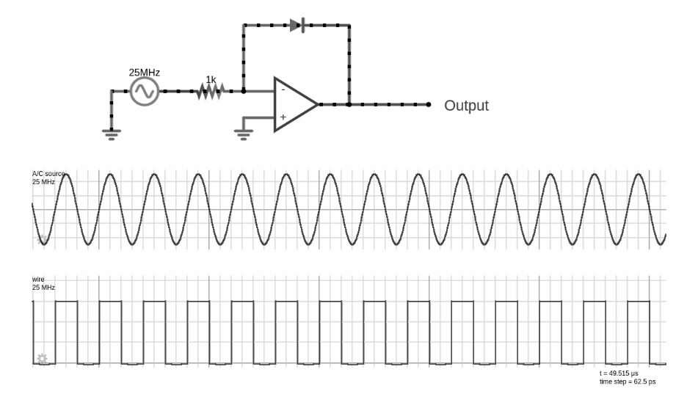

Figure 5‑19: Log amplifier

## I2C

I2C stands for Inter-Integrated Circuit or is called Two Wire Interface (TWI) as it is a two wire serial communication protocol for connecting peripherals to a microcontroller. The I2C require two wire, one Serial Data (SDA) and other Serial Clock (SCL). The SCL is controlled by the Master device i.e. the master generates the clock for communication. Both SCL and SDA lines are open drain drivers meaning that the chip can drive its output low, but it cannot drive high. For the line to be able to go high pull-up resistor to the 5v supply are provided to the I2C bus.

### I2C timing

Each data bit transferred on the SDA line is synchronized by clock on the SCL line. The data line cannot change when the clock line is high, can change only when the clock line is low but the stop and start condition are the only exception to this rule.

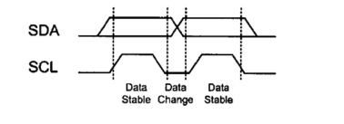

Figure 5‑20: I2C Data bit

I2C is a connection-oriented communication protocol so each transmission is initiated by a start condition and is terminated by a stop condition, which is generated by the master.

In start condition the SDA changes from high to low when SCL is high and in stop condition the SDA changes from low to high when the SCL is high. For reading/writing multiple data continuously to the device connected through the bus, repeated start condition are used, which is as shown below:

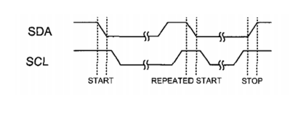

Figure 5‑21: I2C start, stop and repeated start condition

### Data and Address format

Data are of  9 bits long, in which first 8 bits are the data put by the transmitter on the SDA and the 9th bit is for ACK(acknowledge) or NACK(not acknowledge) by receiver, during this time the transmitter release the SDA.

The process is same for address but the 8 bits of address is separated as 7 bits for address and 1 bit for control bit i.e. to specify read and write condition.

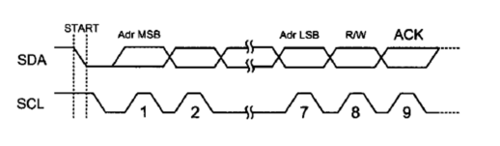

Figure 5‑22: Data and Address format

This protocol was used for interfacing the tuner with microcontroller. The Tuner’s address can be set as per the data given in the datasheet i.e. by applying different voltage level on pin Address select (AS). The table for I2C write mode of tuner is:

Table 5‑3: Write data format

|  |  |  |  |  |  |  |  |  |  |
| --- | --- | --- | --- | --- | --- | --- | --- | --- | --- |
|  | **MSB** |  |  |  |  |  |  | **LSB** |  |
| Address byte (ADB) | 1 | 1 | 0 | 0 | 0 | MA1 | MA0 | R/ = 0 | Ack |
| Divider byte 1 (DB1) | 0 | N14 | N13 | N12 | N11 | N10 | N9 | N8 | Ack |
| Divider byte 2 (DB2) | N7 | N6 | N5 | N4 | N3 | N2 | N1 | N0 | Ack |
| Control Byte (CB) | 1 | CP | T2 | T1 | T0 | RSA | RSB | OS | Ack |
| Band-switch byte (BB) | X | X | X | X | BS4 | BS3 | BS2 | BS1 | Ack |

|  |  |  |
| --- | --- | --- |
| **MA1** | **MA0** | **VOLTAGE APPLIED ON AS INPUT** |
| 0 | 0 | LOW: 0V to 0.1 Vcc |
| 0 | 1 | MID2: open, or 0.2 Vcc to 0.3 Vcc |
| 1 | 0 | MID1: 0.4 Vcc to 0.6 Vcc |
| 1 | 1 | HIGH: 0.9 Vcc TO Vcc |

Table 5‑4: Test bits

|  |  |  |  |  |
| --- | --- | --- | --- | --- |
| **T2** | **T1** | **T0** | **DEVICE OPERATION** | **NOTE** |
| 0 | 0 | 0 | Normal operation |  |
| 0 | 0 | 1 | Normal operation | Default |
| 0 | 1 | X | Charge pump is off |  |
| 1 | 1 | 0 | Charge pump is sink |  |
| 1 | 1 | 1 | Charge pump is source |  |
| 1 | 0 | X | Test mode | ADC not available |

Table 5‑5: Reference Divider ratio

|  |  |  |
| --- | --- | --- |
| **RSA** | **RSB** | **REFERENCE DIVIDER RATIO** |
| X | 0 | 640 |
| 0 | 1 | 1024 |
| 1 | 1 | 512 |

Table 5‑6: band selection

|  |  |  |  |
| --- | --- | --- | --- |
| BS1(VL) | BS2(VH) | BS4(U) |  |
| 1 | 0 | 0 | VHF-LO |
| X | 1 | 0 | VHF-HI |
| X | X | 1 | UHF |

For the N bits:

fr = Reference frequency = 4 MHz/Reference divider

This data is send to tuner with address specified by Address byte (ADB) then continuously data is written to the tuner using the repeated write condition.

# RESULT AND ANALYSIS

The characteristic impedance (Z), capacitive reactance (JX), resistance (R) and standing wave ratio (SWR) are measured using Antenna Analyzer. Readings are taken using balun and without using balun at different frequencies and the result is tabulated below:

Table ‑: Parameters comparison of LPDA

|  |  |  |  |  |  |  |  |  |
| --- | --- | --- | --- | --- | --- | --- | --- | --- |
| Frequency(MHz) | SWR(balunless) | SWR(with balun) | Z(Balunless) | Z(with balun) | R(Balunless) | R(with balun) | Jx(Balunless) | Jx(with Balun) |
| 132.1 | 3.9 | 1.71 | 49 | 79 | 54 | 228 | -68 | -276 |
| 134.1 | 19.9 | 1.54 | 63 | 74 | 169 | 205 | -124 | -191 |
| 136.1 | 5.78 | 1.6 | 47 | 74 | 77 | 207 | -61 | -124 |
| 138.1 | 1.76 | 1.63 | 57 | 74 | 134 | 252 | -143 | -240 |
| 140.1 | 1.5 | 1.72 | 63 | 78 | 217 | 312 | -208 | -302 |
| 142.1 | 19.9 | 1.6 | 79 | 76 | 446 | 269 | -335 | -258 |
| 144.1 | 19.9 | 1.58 | 108 | 75 | 446 | 240 | -335 | -228 |
| 146.1 | 12.7 | 1.59 | 104 | 75 | 446 | 227 | -335 | -214 |
| 148.1 | 2.72 | 1.62 | 86 | 74 | 446 | 230 | -335 | -218 |
| 150.1 | 1.9 | 1.64 | 77 | 74 | 446 | 238 | -335 | -226 |
| 151.1 | 1.87 | 1.51 | 77 | 79 | 137 | 220 | -309 | -208 |
| 152.1 | 1.89 | 6.65 | 76 | 64 | 319 | 446 | -307 | -335 |
| 154.1 | 2.83 | 6.09 | 76 | 65 | 320 | 446 | -311 | -335 |
| 156.1 | 2 | 6 | 78 | 62 | 386 | 426 | -335 | -335 |
| 158.1 | 2.16 | 5.91 | 79 | 62 | 446 | 403 | -335 | -335 |
| 160.1 | 2.19 | 5.03 | 78 | 60 | 446 | 280 | -335 | -273 |

Above data of SWR, Resistance, Impedance and Capacitive Inductance are plotted in graph for the condition of using baluns and without using baluns.

Looking into the graph of SWR, we can observe the difference between SWR of wave while using baluns and not using it. The value of SWR widely varied when the balun was not used and after balun was interfaced, the value remains almost constant around the average of 1.623 upto 150 MHz and varies widely beyond 150MHz.As our antenna was designed for upto 150 MHz, the value of SWR is unpredictable beyond the maximum frequency.

Similarly, the value of impedance, resistance and capacitive inductance and follows the same pattern as that of SWR.The value obtained without using balun was highly deviated from expected. After using balun, the value came to resemble our calculated value with minimum error.

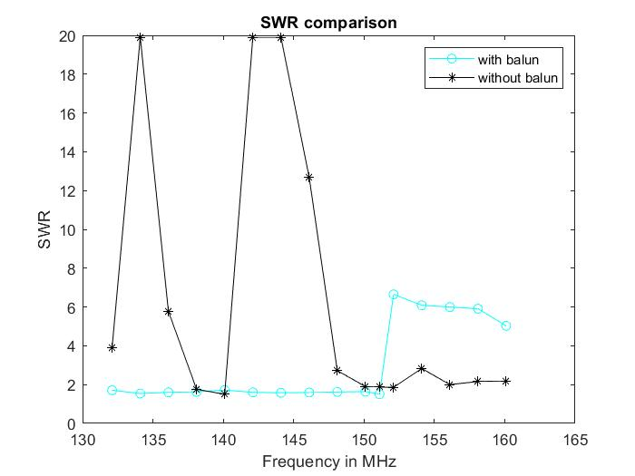

Figure ‑:  Frequency vs. SWR graph with and without balun

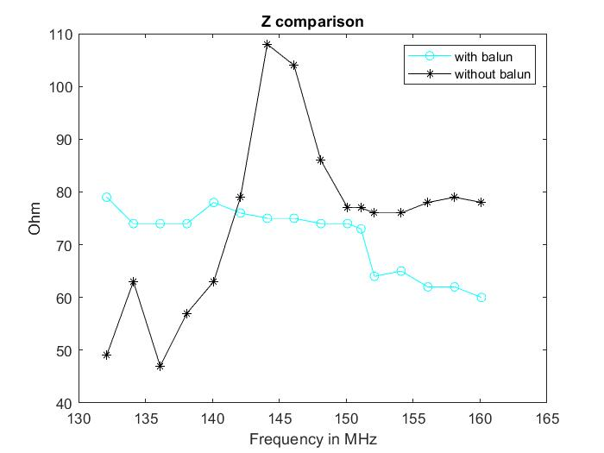

Figure 6‑2:  Frequency vs. Impedance graph with and without balun

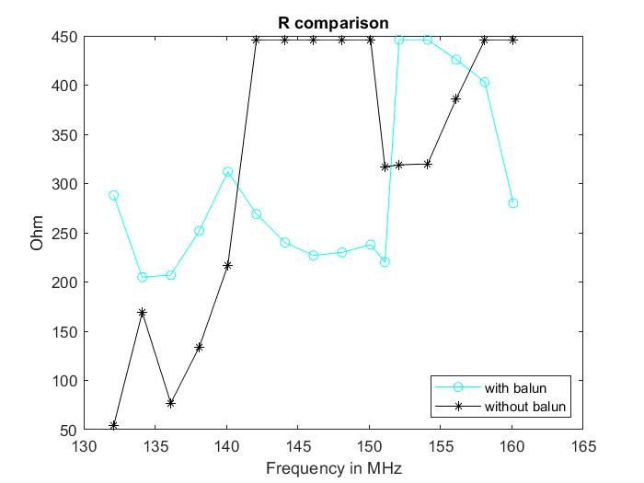

Figure 6‑3: Frequency vs. Resistance graph with and without balun

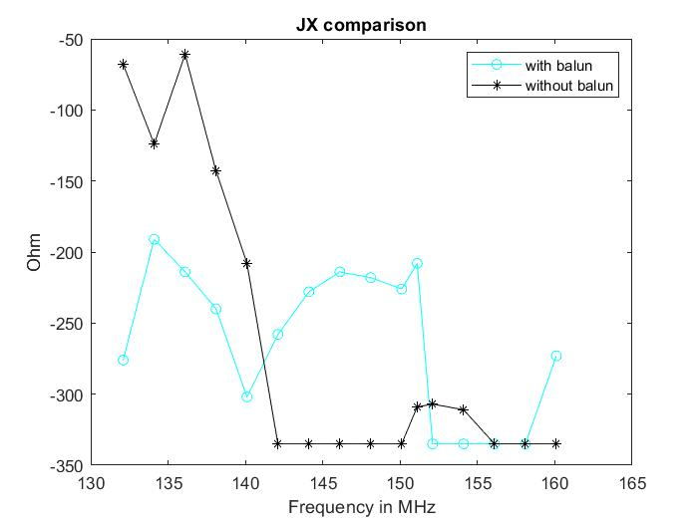

Figure 6‑4: Frequency vs. Capacitive reactance graph with and without balun

As we do not have devices to validate baluns and antenna, we can assure its validity theoretically by observing the value of SWR and Impedance. As we see, the value of SWR agreed theoretical value by using balun, our balun can be validated with minimum error. Similarly, the readings of antenna beyond maximum frequency is found to be changed drastically with higher error than expected value, and it is assured that the antenna is working on its frequency range.

Our designed system for receiving solar radio burst data was analyzed in an open source software called SDR Sharp From this software the data received by LPDA was visualized in graphical form as well as water-fall model as shown in the figure below:

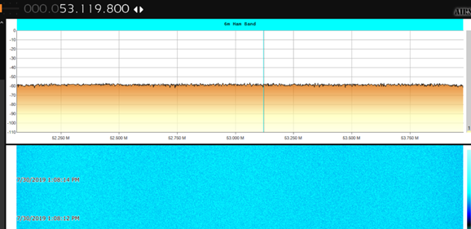

Figure 6‑5:  No signal at 53.119 MHz visualized using SDRSharp

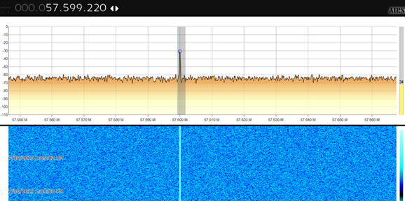

Figure 6‑6:  Signal at 57.599 MHz visualized using SDRSharp

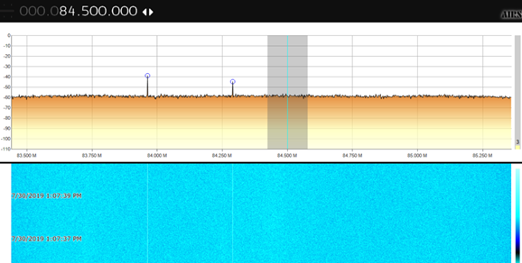

Figure 6‑7:  Signal at 84.5 MHz visualized using SDRSharp

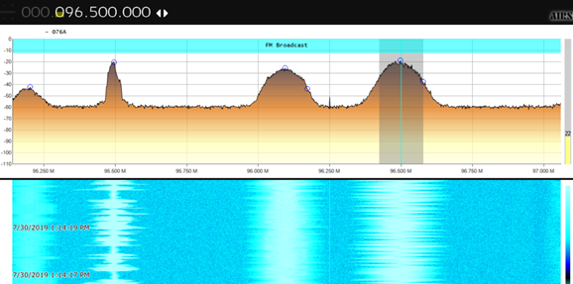

Figure 6‑8:  Different FM signals visualized using SDRSharp

From the above figures we analyzed that there are no signals around 53 MHz during our observation. At 57.6 MHz there was a narrow bandwidth signal having gain of -30dB. The signal may be some modulated signal or any noise signal. Similarly, around 84 MHz, there are some spikes which shows there exist some signal during our time of observation.

On moving to FM band, there are many signals observed that are sent by FM broadcasters. We have observed a band of 96.5 MHz and the signal has higher gain, higher bandwidth and high amplitude compared to the signals of 84 MHz and other non-FM band signals. While observing signals of range greater than FM band, there was some signals received which can be any type of signals or noise at a particular frequency.

## Error analysis

Although we try to make develop our system as precise and as error free as possible there are some errors occurred. Followings are the errors that were observed.

**Impedance**

Impedance of coaxial cable carrying signals should be 75 ohm but practical average impedance was found to be 71.1875.

**SWR**

The maximum standing wave ratio of antenna is 1.5. But when SWR was measured using an antenna analyzer (VNA), the average SWR was noted 1.623, in frequency range upto 150 MHz.

Error percentage are in minimal value, our system is not much affected by this errors. The errors may have occurred due to the following issues:

* Due to error in antenna length and spacing during drilling and fixing of elements.
* Due to improper orientation of antenna limited by its size.
* Due to loss of signals in transmission cable.
* Due to minor errors in construction of balun and un-un. etc.

# FUTURE ENHANCEMENT

There are lots of features and functionalities that can be integrated into our system for obtaining finer data and enhance the performance of the overall system. A better selection of hardware can be done to increase the range of the receiver device which is now limited by a TV tuner capable of handling frequencies from 43MHz to 830MHz. Active components in the receiver can be replaced with components having low noise figures. Furthermore, the antenna can be installed on a solar tracker for better capturing the radio burst signals.

The data regarding solar radio bursts are of great importance in fields such as RF communication, space weather, aviation and space research. A network of such antenna and receiver system can be installed at different places to record the solar radio bursts data at different places at different time intervals and such data can be analyzed to predict the impact of solar radio bursts in RF communication systems, GPS network and so on.

# CONCLUSION

Regarding the concern of solar radio outburst that sometimes causes radio blackouts, our project “Visualization of Solar Radio Outburst” receives frequency of all types ranging from 30MHz to 150MHz. Solar radio outburst occurring in this range is detected and the intensity of the received signals can be then visualized in frequency domain and in the waterfall model.

Analyzing the data and confirming the occurrence of the radio outburst is yet to be achieved. For the analysis of data, we used a device called SDR because of the complexities in receiver design and limitation of time. Proper visualization and analysis of the received signals remains as our motivating factor for further research and study on these topics.

# APPENDIX

## Project Schedule

Table 9‑1: Gantt chart

|  |  |  |  |  |  |  |  |  |  |
| --- | --- | --- | --- | --- | --- | --- | --- | --- | --- |
| Title | 15-May | 25-May | 5-Jun | 15-Jun | 25-Jun | 5-Jul | 15-Jul | 25-Jul | 30-Jul |
| Project Selection |  |  |  |  |  |  |  |  |  |
| Research |  |  |  |  |  |  |  |  |  |
| Proposal Defense |  |  |  |  |  |  |  |  |  |
| Model Development |  |  |  |  |  |  |  |  |  |
| Mid-Defense |  |  |  |  |  |  |  |  |  |
| Testing and Debugging |  |  |  |  |  |  |  |  |  |
| Data Collection |  |  |  |  |  |  |  |  |  |
| Documentation |  |  |  |  |  |  |  |  |  |
| Report Submission |  |  |  |  |  |  |  |  |  |

## Project Budget

Table ‑: Project Budget

|  |  |  |
| --- | --- | --- |
| **S.N.** | **Title** | **Price (In Rs)** |
| 1. | Antenna Element | 900 |
| 2. | Antenna Boom | 950 |
| 3. | Aluminum tape | 475 |
| 4. | Nuts and bolts | 800 |
| 5 | Element Mount | 300 |
| 6. | Zip tie | 300 |
| 7. | Coaxial cable | 400 |
| 8. | Tuner | 250 |
| 9. | Resistors | 20 |
| 10. | 24,22 AWG wire | 120 |
| 11. | Coax Connectors | 150 |
| 12. | Miscellaneous | 1,500 |
|  | **Total** | **5,865** |

## PCB Design Mechanism

**Diode ring mixer**

A circuit for diode ring mixer was made in kicad and was first implemented in matrix board and tested using frequency generator and oscilloscope. The circuit did not work as it meant to because we had to use regular diodes instead of Schottky diode and self-made coupling transformers did not give optimum function.

The following is the schematic for the diode ring mixer:

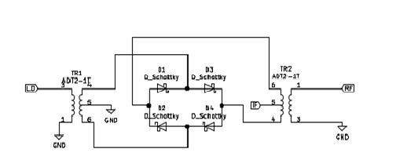

Figure ‑: Diode ring mixer

## Module Specifications

**RTL2831 SDR Receiver:**

As one of the cheapest offers in the market, RTL2831SDR receiver from Teratec manufacturer is an excellent choice for a first approach to the technology. It operates in the VHF and UHF bands, allowing the exploration of a considerable part of the spectrum used for national broadcasts in various applications. It delivers to the DSP stage a spectral width of 32 MHz at real time operation.

Although it comes equipped with a quite small antenna (customizable from 9 to 32cm), the RTL2831 can be connected to other antennas with a better performance, adapted to the bands of intended operation. Moreover, the device has a USB 2.0 port for communicating with the computer, consistent with the spectral width that it handles. Devices able to monitor higher band-widths are commonly connected through a traditional network cable.

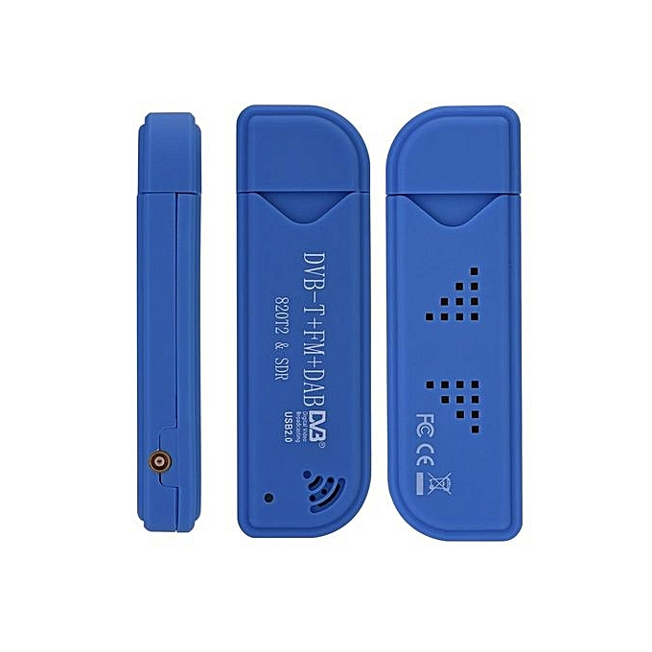

Figure 9‑2: RTL2831 SDR Receive

**SURECOM Color Graphic Antenna Analyzer SA-250:**

SURECOM Antenna analyzer are powerful analyzer designed for testing, checking tuning and repairing antenna and antenna feed lines. Mainly, these are S.W.R (Standing Wave Ratio) and impedance measurement instruments (vector impedance analyzers).

It has a color display which provides a user friendly graphical interface. The frequency range of this particular model are 132 ~ 173 MHz / 200 ~ 260 MHz /400 ~ 519 MHz. It has SMA-Female (50 ohm) connector to connect with antenna. The RF output is 1 - 1.5V (5 - 10 dB). The VSWR range is 1.00 - 19.99. And the Z (Impedance), R (Resistance) and X (Reactance) range is from 0 to 99.9.

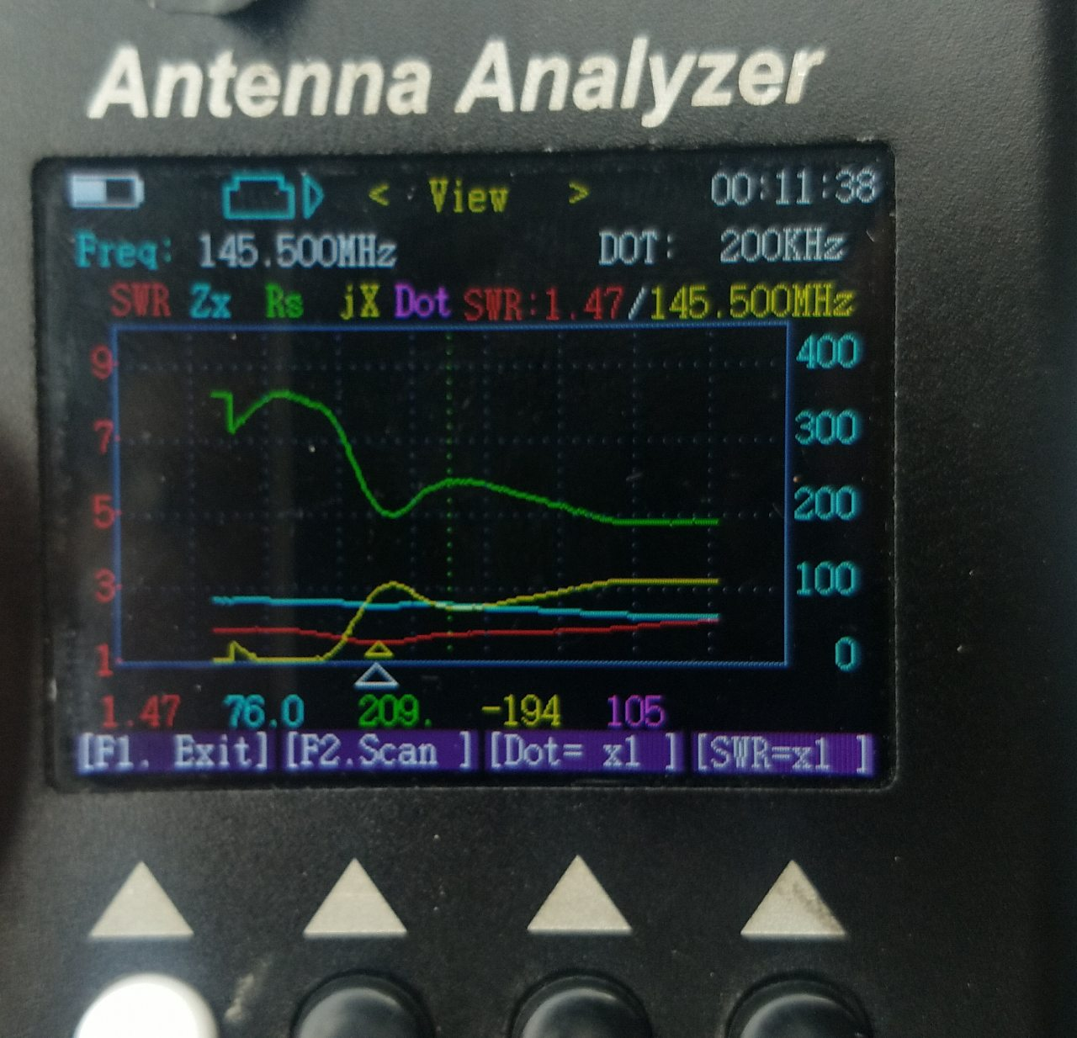

Figure ‑: measurement of characteristic impedance and SWR of LPDA antenna at 145.5 MHz using VNA

# References

|  |  |
| --- | --- |
| [1] | R. Behlke, "Solar radio bursts and low frequency radio emissions from space,," Instituet for Rymdysik Swedish Institute of Space Physics, 2001. |
| [2] | B. o. M. S. W. S. Australian Government, "http://www.sws.bom.gov.au". |
| [3] | "e-CALLISTO," [Online]. Available: www.ecallisto.org. |
| [4] | Dale E. Gary, Louis J. Lanzerotti , Gelu M. Nita and David J. Thomson, "Effects of Solar Radio Bursts on Wireless Systems". |
| [5] | Vasili V. Lobzin, Iver H. Cairns, Peter A. Robinson, Graham Steward, Garth Patterson, "Automatic recognition of type III solar radio bursts:Automated Radio Burst Identification Systemmethod and first observations," *SPACE WEATHER, S04002, doi:10.1029/2008SW000425,* vol. 7, 2009. |
| [6] | M. O. Ali, Z. S. Hamidi, N. N. M. Shariff, M. S. Faid, S. N. U. Sabri, N. Husien, N. H. Zainol C. Monstein,. , " e-CALLISTO Network System and the Observation of Structure of Solar Radio Burst Type III," 2017. |
| [7] | Z. S. Hamidi, N. N. M. Shariff , C. Monstein, International Letters of Chemistry, Physics and Astronomy, vol. 32, Switzerland: SciPress Ltd, 2014, pp. 144-154. |
| [8] | K. C. Fox, " X-class: A Guide to Solar Flares," 2011. |
| [9] | M. A. K. d. J. V. Sreeja, "Impact of the 24 September 2011 solar radio burst on the performance of GNSS receivers," *Space Weather,* 2013. |
| [10] | "American Meteorological Society & SolarMetrics Policy Workshop Report,Integrating Space Weather Observations & Forecasts into Aviation Operations," 2007. |
| [11] | H. Stetson, "The Sun and Climate,", McGraw Hill, 1937., 2005. |
| [12] | Frantisek Hutira, Jan Bezek, Vladimir Bilik, "DESIGN AND INVESTIGATION OF A LOG-PERIODIC ANTENNA," *S-TEAM Lab, Chrobakova 2.* |
| [13] | Md Sarwar Hossain Muhammad Sajjad Hussain, "Comparative Analysis between Homodyne and Heterodyne Receiver Architecture". |
|  |  |